

**CSC 621: Database Systems**

**Dr. Mary Krueger & Dr. Alan Nochenson**

**Final Report**

**By:**

**Mohammed Alamoudi, Mohammed Al Duniawi, Hemanth Nalamothu, Victor Logan**

**Date: Dec/06/2016**

**Hospital Management System**

**Description:**

The project that our group will be working on is a Hospital Management System, HMS. The System will be used by a hospital to keep the records of patients and manage the appointments for patients with doctors in the hospital and the cost of visits and operations for patients.

HMS will record and keep track of patients, appointments, bills, employees, login info, and department. Each patient will have a unique patient ID, First Name, Last name, Date of birth, Address, and Contact. Each appointment will have a unique Appointment ID, Appointment Date, Appointment Time, prescription, comments from doctor and appointment status. Each Bill will have a unique Bill ID, pending amount, Bill amount, and paid status. Each employee will have a unique employee ID, type of employment, image, First Name, Last Name, Address, Contact, Start Date and End Date.

There will be four users; The patient, the doctor, the receptionist, and the administrator. The patient can view and update their personal information. They can view bills and make a payment. The doctor can view and update their personal information. The doctor can see their list of appointments and reschedule if need be. The doctor can also make comments on appointments. The receptionist can register patients and create/edit appointments. The administrator can create and edit employees, doctors, and receptionists.

In terms of queries that will be supported, there will be create/insert, read/select, update and delete/remove. It will be Create New Patient, employee, Doctor, Receptionist, Admin, and new appointment. Read/display current appointments and view personal information. Update personal information, make payments, change appointments. Delete patient, appointment, doctor, and receptionist. In general, the Doctor will be able to Select, Update, and insert. The receptionist will be able to Insert, Select, Update, and Delete. The Admin will be able to Insert, Update, Delete, Create, and Select.

A patient can have one set of login details. A Patient can have one or many bills and a bill can only have one patient. An employee can be a doctor, a receptionist, or an admin. An employee can have one set of login details. A doctor can have one or many appointments. An appointment can be seen by one or many doctors. An appointment can have one bill and a bill can belong to one appointment.

A Delete Restriction is that a department record must not be deleted if its primary key value is referred to by a foreign key value. If an employee record is deleted from the Employee table, all foreign keys that refer to the primary key of this record will also be deleted. If a patient record is deleted from the patient table, all foreign keys that refer to the primary key of this record will also be deleted.

**ER diagram:**

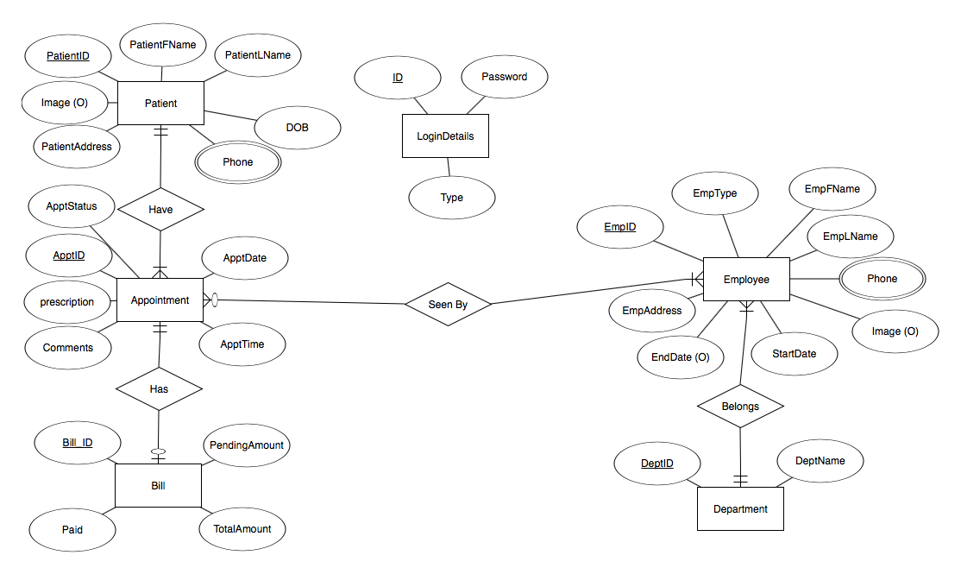

**Relational model:**

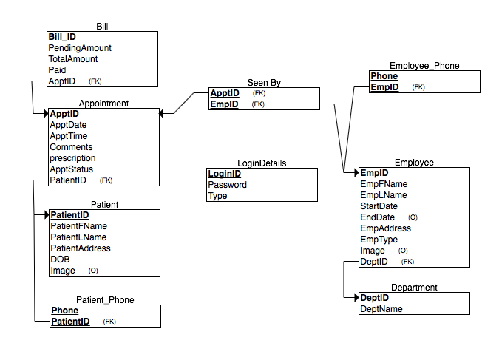

**Database Requirements:**

HMS is a Hospital Management System that manages their Patients appointments bills and (*) Payments (*).

* HMS is will keep track of its patients, Appointment, Bill, employees, Login details, department. (*) Transactions, Bill details and daily log (*)
* For each patient, HMS will keep track of unique patient ID, First Name, Last Name, Date of birth, Address, Contact, Image.
* For Each appointment, HMS will keep track of unique Appointment ID, Appointment Date, Appointment Time, prescription, Comments from Doctor and appointment status.
* For each Bill, HMS will keep track of unique Bill ID, Pending Amount, Bill Amount, Paid status and (*) multiple *Bill details* (*).
* For each employee, HMS will keep track of unique Employee ID, type of Employment, Image, First Name, Last Name, Address, Contact, Start Date and End Date.
* A Patient can schedule one or many appointments. An Appointment should be for only one patient. HSM will NOT keep track of Patients with no appointment.
* For Each Login details, HMS will keep track of Login ID and Password.
* A Patient can have one Login details
* A Patient can have one or many bills. A bill will belong to one Patient.
* An employee can be doctor or Receptionist or Admin
* An employee can have one Login details
* A Doctor can take one or many appointments. An Appointment can be seen by only one or many Doctors.
* An appointment can have one bill. A Bill belong to one Appointment.

(*) Optional may add into the project if time favors.

**Users:**

**Patients:**

* View/Update their personal information
* View Bills
* Make a Payment
* View / Cancel Appointment

**Doctor:**

* View/Update their personal information
* See the list of appointments.
* (*) Update Patient Status (*)
* Reschedule an appointment for patient
* Make comment/Note for appointment

**Receptionist:**

* Register new Patient
* Search for patient by:
  + Patient ID
  + First name
  + Last Name
  + Date of birth
  + Search between two dates of birth
* Make appointments
* Appointment search based on:
  + Patient’s first name
  + Patient’s last Name
  + Patient’s date of birth
  + Appointment ID
  + Appointment date
  + Appointment time
  + Appointment status
  + Patient ID
  + Search between two appointment dates
* Update/delete appointment
* Update/delete patient

**Admin:**

* Create/Update/Delete Employees, Doctors, Receptionists
* Reset Passwords
* Doctor report based on
  + Month
  + Month and Year
  + Including employees not working currently
* Financial report based on
  + Month
  + Month and year

**Queries:**

* **Create**
* Create new Patient, Employee, Doctor, Receptionist, Admin.
* Create new Appointment.
* **Read**
* Read/display current Appointments.
* View personal information, Bills.
* **Update**
* Update personal information
* Make Payments
* Change appointment
* **Delete**
* Delete Patient, Appointment
* Delete Doctor, Receptionist.

**FD Closure:**

In our project all the tables are in the 3rd normalization phase and the tables will be as:

**Appointment**

|  |  |  |  |  |
| --- | --- | --- | --- | --- |
| **Column** | **Type** | **Can Be Null** | **Foreign Key to** | **Comments** |
| ApptID | int(11) | no |  |  |
| AppDate | date | no |  |  |
| AppTime | time | no |  |  |
| Comments | varchar(1000) | yes |  |  |
| Prescription | varchar(500) | yes |  |  |
| ApptStatus | varchar(25) | yes |  |  |
| PatientID | int(11) | no | PatientID in Patient table |  |

**Bill**

|  |  |  |  |  |
| --- | --- | --- | --- | --- |
| Column | Type | Can Be Null | Foreign Key to | Comments |
| BillID | int(11) | no |  |  |
| PendingAmount | decimal(10,2) | no |  |  |
| TotalAmount | decimal(10,2) | no |  |  |
| Paid | decimal(10,2) | no |  |  |
| ApptID | int(11) | no | ApptID in Appointment table |  |

**Department**

|  |  |  |  |  |
| --- | --- | --- | --- | --- |
| **Column** | **Type** | **Can Be Null** | **Foreign Key to** | **Comments** |
| DeptID | int(11) | no |  |  |
| DeptName | varchar(50) | no |  |  |

**Employee**

|  |  |  |  |  |
| --- | --- | --- | --- | --- |
| **Column** | **Type** | **Can Be Null** | **Foreign Key to** | **Comments** |
| EmpID | int(11) | no |  |  |
| EmpFName | varchar(40) | no |  |  |
| EmpLName | varchar(40) | no |  |  |
| StartDate | date | no |  |  |
| EndDate | date | yes |  |  |
| EmpAddress | varchar(50) | no |  |  |
| EmpType | varchar(15) | no |  |  |
| Image | longblob | yes |  |  |
| DeptID | int(11) | no | DeptID in Department table |  |

**Employee_Phone**

|  |  |  |  |  |
| --- | --- | --- | --- | --- |
| **Column** | **Type** | **Can Be Null** | **Foreign Key to** | **Comments** |
| Phone | varchar(15) | no |  |  |
| EmpID | int(11) | no | EmpID in Employee table |  |

**LoginDetails**

|  |  |  |  |  |
| --- | --- | --- | --- | --- |
| **Column** | **Type** | **Can Be Null** | **Foreign Key to** | **Comments** |
| LoginID | int(11) | no |  |  |
| Password | varchar(100) | no |  |  |
| Type | varchar(15) | no |  |  |

**Patient**

|  |  |  |  |  |
| --- | --- | --- | --- | --- |
| **Column** | **Type** | **Can Be Null** | **Foreign Key to** | **Comments** |
| PatientID | int(11) | no |  |  |
| PatientFName | varchar(25) | no |  |  |
| PatientLName | varchar(25) | no |  |  |
| PatientAddress | varchar(100) | yes |  |  |
| DOB | date | no |  |  |
| Image | longblob | yes |  |  |

**Patient_Phone**

|  |  |  |  |  |
| --- | --- | --- | --- | --- |
| **Column** | **Type** | **Can Be Null** | **Foreign Key to** | **Comments** |
| Phone | varchar(15) | no |  |  |
| PatientID | int(11) | no | PatientID in Patient table |  |

**SeenBy**

|  |  |  |  |  |
| --- | --- | --- | --- | --- |
| **Column** | **Type** | **Can Be Null** | **Foreign Key to** | **Comments** |
| ApptID | int(11) | no | ApptID in Appointment table |  |
| EmpId | int(10) | no | EmpID in Employee table |  |

**SQL for creation and population of the tables:**

--

-- Table structure for table `appointment`

--

CREATE TABLE `Appointment` (

`ApptID` int(11) NOT NULL,

`ApptDate` date NOT NULL,

`ApptTime` time NOT NULL,

`Comments` varchar(1000) DEFAULT NULL,

`Prescription` varchar(500) DEFAULT NULL,

`ApptStatus` varchar(400) DEFAULT NULL,

`PatientID` int(11) NOT NULL

) ENGINE=InnoDB DEFAULT CHARSET=latin1;

--

-- Dumping data for table `appointment`

--

INSERT INTO `Appointment` (`ApptID`, `ApptDate`, `ApptTime`, `Comments`, `Prescription`, `ApptStatus`, `PatientID`) VALUES

(5601, '2017-04-04', '09:30:00', NULL, NULL, 'closed', 198001),

(5602, '2017-01-16', '11:34:00', 'needs to pay', NULL, 'closed', 198002),

(5603, '2016-08-08', '08:36:00', NULL, 'placebo', 'closed', 198003),

(5604, '2016-02-10', '14:50:00', 'May reschedule', '2 bottles', '12008', 198004),

(5605, '2016-06-22', '11:32:00', NULL, '3.5 bottles', 'closed', 198005),

(5606, '2017-02-02', '14:45:00', 'Child', 'none', '12017', 198006),

(5607, '2017-02-08', '10:15:00', 'Needs to schedule another appointment', 'rest', '12018', 198007),

(5608, '2016-05-31', '13:30:00', NULL, NULL, 'closed', 198008),

(5609, '2017-01-05', '09:15:00', 'Needs to schedule for child', '1 bottle', '12004', 198009),

(5610, '2016-11-22', '11:15:00', NULL, NULL, '12005', 198010),

(5611, '2016-10-11', '13:15:00', 'x-rays needed', NULL, 'closed', 198011),

(5612, '2017-01-12', '10:15:00', 'none', '4 bottles', '12011', 198012),

(5613, '2016-06-29', '14:35:00', 'is a child', 'Children''s tylenol', '12017', 198013),

(5614, '2016-10-24', '10:15:00', 'Needs blood work done', '2 bottles', 'closed', 198014),

(5615, '2016-09-20', '09:30:00', NULL, 'physical rehab', 'closed', 198015),

(5616, '2017-02-02', '13:45:00', 'needs to schedule a physical', NULL, 'closed', 198016),

(5617, '2016-05-17', '15:30:00', 'issues with payment', NULL, 'closed', 198017),

(5618, '2017-06-14', '15:30:00', NULL, NULL, '12005', 198018),

(5619, '2017-04-21', '13:29:00', 'Needs to pay', NULL, '12008', 198019),

(5620, '2017-07-13', '10:15:00', NULL, NULL, '12011', 198020);

-- --------------------------------------------------------

--

-- Table structure for table `bill`

--

CREATE TABLE `Bill` (

`BillId` int(11) NOT NULL,

`PendingAmount` decimal(10,2) NOT NULL,

`TotalAmount` decimal(10,2) NOT NULL,

`Paid` decimal(10,2) NOT NULL,

`ApptID` int(11) NOT NULL

) ENGINE=InnoDB DEFAULT CHARSET=latin1;

--

-- Dumping data for table `bill`

--

INSERT INTO `Bill` (`BillId`, `PendingAmount`, `TotalAmount`, `Paid`, `ApptID`) VALUES

(623001, '100.00', '1000.00', '900.00', 5601),

(623021, '50.00', '1000.00', '950.00', 5602),

(623022, '0.00', '10.00', '10.00', 5603),

(623023, '80.00', '100.00', '20.00', 5604),

(623024, '150.00', '300.00', '150.00', 5605),

(623025, '50.00', '100.00', '50.00', 5606),

(623026, '25.00', '50.00', '25.00', 5607),

(623027, '0.00', '100.00', '100.00', 5608),

(623028, '20.00', '40.00', '20.00', 5609),

(623029, '0.00', '750.00', '750.00', 5610),

(623030, '0.00', '700.00', '700.00', 5611),

(623031, '0.00', '600.00', '600.00', 5612),

(623032, '0.00', '730.00', '730.00', 5613),

(623033, '30.00', '90.00', '60.00', 5614),

(623034, '20.00', '80.00', '60.00', 5615),

(623035, '500.00', '1100.00', '600.00', 5616),

(623036, '25.00', '100.00', '75.00', 5617),

(623037, '20.00', '100.00', '80.00', 5618),

(623038, '75.00', '150.00', '75.00', 5619),

(623039, '0.00', '150.00', '150.00', 5620);

-- --------------------------------------------------------

--

-- Table structure for table `department`

--

CREATE TABLE `Department` (

`DeptId` int(11) NOT NULL,

`DeptName` varchar(50) NOT NULL

) ENGINE=InnoDB DEFAULT CHARSET=latin1;

--

-- Dumping data for table `department`

--

INSERT INTO `Department` (`DeptId`, `DeptName`) VALUES

(1, 'Surgeon'),

(2, 'Accounts'),

(3, 'Administration');

-- --------------------------------------------------------

--

-- Table structure for table `employee`

--

CREATE TABLE `Employee` (

`EmpID` int(11) NOT NULL,

`EmpFName` varchar(40) NOT NULL,

`EmpLName` varchar(40) NOT NULL,

`StartDate` date NOT NULL,

`EndDate` date DEFAULT NULL,

`EmpAddress` varchar(50) NOT NULL,

`EmpType` varchar(15) NOT NULL,

`Image` longblob,

`DeptID` int(11) NOT NULL

) ENGINE=InnoDB DEFAULT CHARSET=latin1;

--

-- Dumping data for table `employee`

--

INSERT INTO `Employee` (`EmpID`, `EmpFName`, `EmpLName`, `StartDate`, `EndDate`, `EmpAddress`, `EmpType`, `Image`, `DeptID`) VALUES

(12001, 'Hemanth', 'Nalamothu', '2016-10-11', NULL, 'Penn', 'Doctor', NULL, 1),

(12002, 'Tom', 'Keen', '2016-09-13', NULL, 'New York', 'recep', NULL, 2),

(12003, 'John', 'Smith', '2016-08-16', NULL, '5600, City ave.', 'Admin', NULL, 3),

(12004, 'Jimmy', 'Carter', '2016-08-16', NULL, 'Lansdale avenue', 'Doctor', NULL, 1),

(12005, 'Monkey', 'Luffy', '2016-08-16', NULL, 'Grandline ave', 'Doctor', NULL, 1),

(12006, 'Roanoa', 'Zoro', '2015-04-15', '2016-08-09', 'New Jersey', 'Admin', NULL, 3),

(12007, 'Ryan', 'Howard', '2016-06-14', NULL, 'Philadelphia', 'recep', NULL, 2),

(12008, 'John', 'Jaskal', '2015-06-09', NULL, 'Jacksonville', 'Doctor', NULL, 1),

(12009, 'Michael', 'Johnson', '2016-01-04', '2016-12-01', 'Park Avenue', 'recep', NULL, 2),

(12010, 'Chris', 'Redfield', '2016-08-16', NULL, 'Jacksonville', 'Admin', NULL, 3),

(12011, 'will', 'Arnett', '2016-02-08', NULL, 'Kentucky', 'Doctor', NULL, 1),

(12012, 'Son', 'Goku', '2015-03-17', '2015-11-25', 'West City', 'recep', NULL, 2),

(12013, 'Jimmy', 'Neutron', '2016-03-06', NULL, 'Retroville', 'recep', NULL, 2),

(12014, 'Barack', 'Obama', '2015-02-01', '2016-12-01', 'Washington', 'Admin', NULL, 3),

(12015, 'Bill', 'Burr', '2016-02-08', NULL, 'Lancaster Ave', 'recep', NULL, 2),

(12016, 'Ryan', 'Reynolds', '2016-03-07', '2016-12-08', 'California', 'recep', NULL, 2),

(12017, 'Ronald', 'Mcdonald', '2015-12-16', NULL, 'New York', 'Doctor', NULL, 1),

(12018, 'Regina', 'King', '2015-09-21', NULL, 'Florida', 'Doctor', NULL, 1),

(12019, 'Kim', 'Possible', '2015-01-05', '2016-09-15', '5600, City ave.', 'Admin', NULL, 3),

(12020, 'John', 'Smith', '2016-08-16', NULL, '5600, City ave.', 'Admin', NULL, 3);

-- --------------------------------------------------------

--

-- Table structure for table `employee_phone`

--

CREATE TABLE `Employee_Phone` (

`Phone` varchar(15) NOT NULL,

`EmpID` int(10) NOT NULL

) ENGINE=InnoDB DEFAULT CHARSET=latin1;

--

-- Dumping data for table `employee_phone`

--

INSERT INTO `Employee_Phone` (`Phone`, `EmpID`) VALUES

('1009568348', 12010),

('1213456572', 12003),

('1234567890', 12002),

('2205683643', 12011),

('2348907685', 12019),

('2647692546', 12005),

('4280646386', 12009),

('4762107437', 12005),

('5439086574', 12017),

('5853551617', 12001),

('7094327654', 12013),

('7396738753', 12004),

('8096549876', 12014),

('8300348641', 12006),

('8569085423', 12018),

('9069872314', 12012),

('9081233243', 12016),

('9084532387', 12015),

('9094563214', 12020),

('9150275614', 12008),

('9351257642', 12007);

-- --------------------------------------------------------

--

-- Table structure for table `logindetails`

--

CREATE TABLE `LoginDetails` (

`ID` int(10) NOT NULL,

`Password` varchar(100) NOT NULL,

`Type` varchar(10) NOT NULL

) ENGINE=InnoDB DEFAULT CHARSET=latin1;

--

-- Dumping data for table `logindetails`

--

INSERT INTO `LoginDetails` (`ID`, `Password`, `Type`) VALUES

(12001, 'ba3abb2c0cb388f3cd4e77de3c78ff51', 'Doctor'),

(12002, 'f6bc0623a4ab517ae89db46f368c09c4', 'recep'),

(12003, 'd2a9aaedbe3616c7be11e07856c29e2a', 'Admin'),

(12004, 'dsjlkdhsdoiyhlkefjlkio8732667786423a', 'Doctor'),

(12005, '897hjghgftye453ryguhf78i6u8', 'Doctor'),

(12006, 'kjhuihiug765786gyufv756578tg7ub78g', 'Admin'),

(12007, 'kjbkhjg78tgiujb76476t998iuo987908yhouih', 'recep'),

(12008, 'jkhg7647564567c764576t786', 'Doctor'),

(12009, '876iughkjbyut76785674756456e56edjhfty7767', 'recep'),

(12010, 'kuhg87687678tgyvg7868hjkhg7868', 'Admin'),

(198001, 'c6e53a7e82a4138b330b17c4a91267a1', 'Patient'),

(198002, 'c787979eokjllksdjfo8d97f9asudofij', 'Patient'),

(198003, 'hsjdlfkajskldfj92387r98324759iuou985798', 'Patient'),

(198004, '7868sdf87sad6f87sdfsdaf', 'Patient'),

(198005, '8698y5iuhjkhsd9uifg6238974', 'Patient'),

(198006, '78678hjbvjhkg875786tg778g78buhbg', 'Patient'),

(198007, '78678hjbvjhkg875786tg778g78buhbg', 'Patient'),

(198008, 'kjh876897678tgbv876897', 'Patient'),

(198009, '987hjkjk8768676hu0897hjk', 'Patient'),

(198010, 'kjhg78687678ijkgh87587tui', 'Patient');

-- --------------------------------------------------------

--

-- Table structure for table `patient`

--

CREATE TABLE `Patient` (

`PatientID` int(11) NOT NULL,

`PatientFName` varchar(25) NOT NULL,

`PatientLName` varchar(25) NOT NULL,

`PatientAddress` varchar(100) DEFAULT NULL,

`DOB` date NOT NULL,

`Image` longblob

) ENGINE=InnoDB DEFAULT CHARSET=latin1;

--

-- Dumping data for table `patient`

--

INSERT INTO `Patient` (`PatientID`, `PatientFName`, `PatientLName`, `PatientAddress`, `DOB`, `Image`) VALUES

(198001, 'Mohammed', 'Alamoudi', 'Lancaster Ave. , Philadelphia, Pa', '1990-12-11', NULL),

(198002, 'Victor', 'Logan', 'City Ave. , Philadelphia, Pa', '1994-03-11', NULL),

(198003, 'Jack', 'Johnson', 'Park ave, Pleasantville, Pa', '1997-09-10', NULL),

(198004, 'Jimmy', 'Carter', 'lapsely lane , Philadelphia, Pa', '1980-03-11', NULL),

(198005, 'Joel', 'Velez', 'Pierce Street , Philadelphia, Pa', '1995-02-11', NULL),

(198006, 'Emmanuel', 'Johnson', 'Pierce St. , Philadelphia, Pa', '1989-06-23', NULL),

(198007, 'Jimmy', 'Johnson', 'New York', '1991-05-16', NULL),

(198008, 'Jess', 'Carsel', 'Kentucky', '1989-08-08', NULL),

(198009, 'Mary', 'Krueger', 'Pennsylvania', '1991-04-18', NULL),

(198010, 'jennifer', 'Aniston', 'Pennsylvania ', '1989-04-09', NULL),

(198011, 'Sarah', 'Jones', 'New Jersey', '1991-08-13', NULL),

(198012, 'Will', 'Johnson', 'Massachusetts ', '1989-05-16', NULL),

(198013, 'Matt', 'Patt', 'Texas', '1993-04-21', NULL),

(198014, 'KYLE', 'Chambley', 'Pennsylvania ', '1989-10-18', NULL),

(198015, 'Gio', 'Vencenzo', 'New Jersey', '1991-04-16', NULL),

(198016, 'Bruce', 'Springsteen', 'California', '1989-06-06', NULL),

(198017, 'Jeff', 'Bakular', 'Pennsylvania', '1992-05-19', NULL),

(198018, 'Colonel', 'Sanders', 'Florida', '1989-11-21', NULL),

(198019, 'John', 'Richards', 'Pennsylvania ', '1989-01-19', NULL),

(198020, 'kim', 'Possible', 'New Jersey', '1990-07-23', NULL);

-- --------------------------------------------------------

--

-- Table structure for table `patient_phone`

--

CREATE TABLE `Patient_Phone` (

`Phone` char(15) NOT NULL,

`PatientID` int(11) NOT NULL

) ENGINE=InnoDB DEFAULT CHARSET=latin1;

--

-- Dumping data for table `patient_phone`

--

INSERT INTO `Patient_Phone` (`Phone`, `PatientID`) VALUES

('0500111405', 198001),

('2156099039', 198002),

('9061438546', 198003),

('6450982314', 198004),

('7094386754', 198005),

('7094239876', 198006),

('5762097865', 198007),

('4397687456', 198008),

('9084897865', 198009),

('3908763409', 198010),

('6459086754', 198011),

('6472340987', 198012),

('7589072345', 198013),

('7684569567', 198014),

('7684989087', 198015),

('6547894567', 198016),

('7560983456', 198017),

('6785430989', 198018),

('8794560789', 198019),

('8795766987', 198020);

-- --------------------------------------------------------

--

-- Table structure for table `seenby`

--

CREATE TABLE `SeenBy` (

`ApptID` int(11) NOT NULL,

`EmpId` int(10) NOT NULL

) ENGINE=InnoDB DEFAULT CHARSET=latin1;

--

-- Dumping data for table `seenby`

--

INSERT INTO `SeenBy` (`ApptID`, `EmpId`) VALUES

(5601, 12001),

(5602, 12004),

(5603, 12005),

(5604, 12008),

(5605, 12011),

(5606, 12017),

(5607, 12018),

(5608, 12001),

(5609, 12004),

(5610, 12005),

(5611, 12008),

(5612, 12011),

(5613, 12017),

(5614, 12018),

(5615, 12001),

(5616, 12001),

(5617, 12004),

(5618, 12005),

(5619, 12008),

(5620, 12011);

--

-- Indexes for dumped tables

--

--

-- Indexes for table `appointment`

--

ALTER TABLE `Appointment`

ADD PRIMARY KEY (`ApptID`),

ADD KEY `PatientID` (`PatientID`);

--

-- Indexes for table `bill`

--

ALTER TABLE `Bill`

ADD PRIMARY KEY (`BillId`),

ADD KEY `ApptID` (`ApptID`);

--

-- Indexes for table `department`

--

ALTER TABLE `Department`

ADD PRIMARY KEY (`DeptId`);

--

-- Indexes for table `employee`

--

ALTER TABLE `Employee`

ADD PRIMARY KEY (`EmpID`),

ADD KEY `DeptID` (`DeptID`);

--

-- Indexes for table `employee_phone`

--

ALTER TABLE `Employee_Phone`

ADD PRIMARY KEY (`Phone`,`EmpID`),

ADD KEY `EmpID` (`EmpID`);

--

-- Indexes for table `logindetails`

--

ALTER TABLE `LoginDetails`

ADD PRIMARY KEY (`ID`);

--

-- Indexes for table `patient`

--

ALTER TABLE `Patient`

ADD PRIMARY KEY (`PatientID`);

--

-- Indexes for table `patient_phone`

--

ALTER TABLE `Patient_Phone`

ADD PRIMARY KEY (`PatientID`,`Phone`);

--

-- Indexes for table `seenby`

--

ALTER TABLE `SeenBy`

ADD PRIMARY KEY (`ApptID`,`EmpId`),

ADD KEY `EmpID` (`EmpId`);

--

-- AUTO_INCREMENT for dumped tables

--

--

-- AUTO_INCREMENT for table `appointment`

--

ALTER TABLE `Appointment`

MODIFY `ApptID` int(11) NOT NULL AUTO_INCREMENT, AUTO_INCREMENT=5621;

--

-- AUTO_INCREMENT for table `bill`

--

ALTER TABLE `Bill`

MODIFY `BillId` int(11) NOT NULL AUTO_INCREMENT, AUTO_INCREMENT=623040;

--

-- AUTO_INCREMENT for table `department`

--

ALTER TABLE `Department`

MODIFY `DeptId` int(11) NOT NULL AUTO_INCREMENT, AUTO_INCREMENT=4;

--

-- AUTO_INCREMENT for table `employee`

--

ALTER TABLE `Employee`

MODIFY `EmpID` int(11) NOT NULL AUTO_INCREMENT, AUTO_INCREMENT=12021;

--

-- AUTO_INCREMENT for table `patient`

--

ALTER TABLE `Patient`

MODIFY `PatientID` int(11) NOT NULL AUTO_INCREMENT, AUTO_INCREMENT=198021;

--

-- Constraints for dumped tables

--

--

-- Constraints for table `appointment`

--

ALTER TABLE `Appointment`

ADD CONSTRAINT `appointment_ibfk_1` FOREIGN KEY (`PatientID`) REFERENCES `Patient` (`PatientID`) ON DELETE CASCADE;

--

-- Constraints for table `bill`

--

ALTER TABLE `Bill`

ADD CONSTRAINT `bill_ibfk_1` FOREIGN KEY (`ApptID`) REFERENCES `Appointment` (`ApptID`) ON DELETE CASCADE;

--

-- Constraints for table `employee`

--

ALTER TABLE `Employee`

ADD CONSTRAINT `employee_ibfk_1` FOREIGN KEY (`DeptID`) REFERENCES `Department` (`DeptId`) ON DELETE CASCADE ON UPDATE CASCADE;

--

-- Constraints for table `employee_phone`

--

ALTER TABLE `Employee_Phone`

ADD CONSTRAINT `employee_phone_ibfk_1` FOREIGN KEY (`EmpID`) REFERENCES `Employee` (`EmpID`) ON DELETE CASCADE ON UPDATE CASCADE;

--

-- Constraints for table `patient_phone`

--

ALTER TABLE `Patient_Phone`

ADD CONSTRAINT `patient_phone_ibfk_1` FOREIGN KEY (`PatientID`) REFERENCES `Patient` (`PatientID`) ON DELETE CASCADE ON UPDATE CASCADE;

--

-- Constraints for table `seenby`

--

ALTER TABLE `SeenBy`

ADD CONSTRAINT `seenby_ibfk_1` FOREIGN KEY (`EmpId`) REFERENCES `Employee` (`EmpID`) ON DELETE CASCADE ON UPDATE CASCADE,

ADD CONSTRAINT `seenby_ibfk_2` FOREIGN KEY (`ApptID`) REFERENCES `Appointment` (`ApptID`) ON DELETE CASCADE ON UPDATE CASCADE;

**Discuss how you anticipate the application to be used and how this drove your design:**

This application is developed to be used by specific hospital for organizing appointments and keep track of the cost of visits and operations for patients. This application is designed to be used by four types of users: patient, doctor, receptionist, and the administrator

**Interfaces:**

**Log In:**

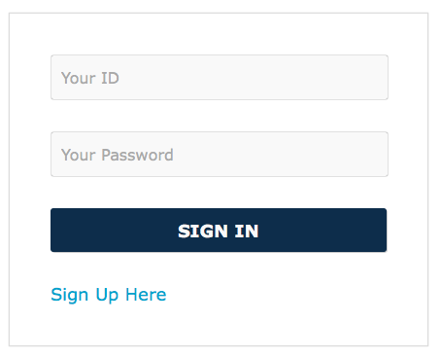

**Sign Up:**

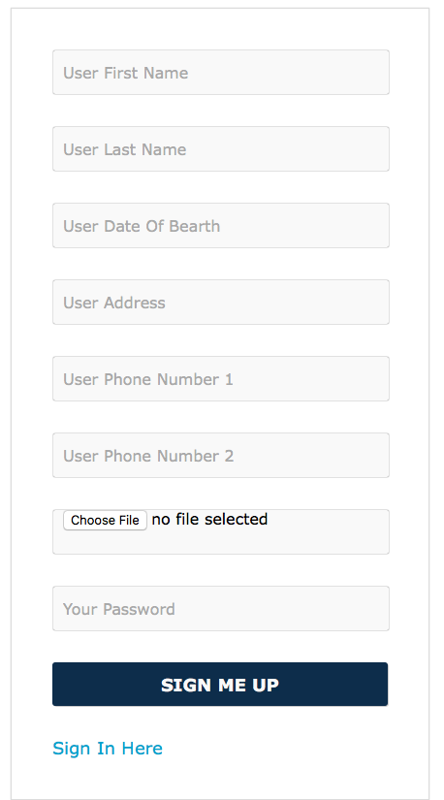

**Receptionist Interface:**

New Patient:

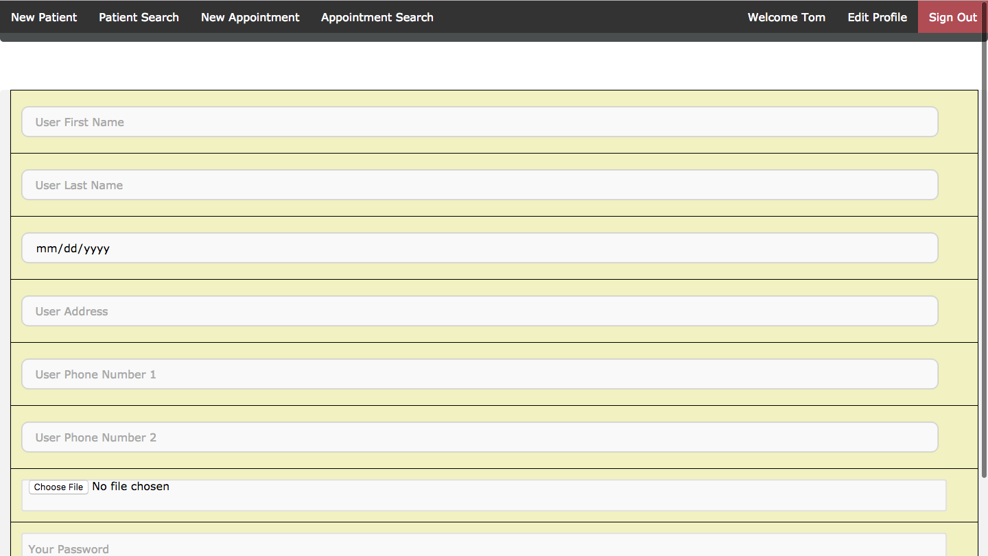

Patient search:

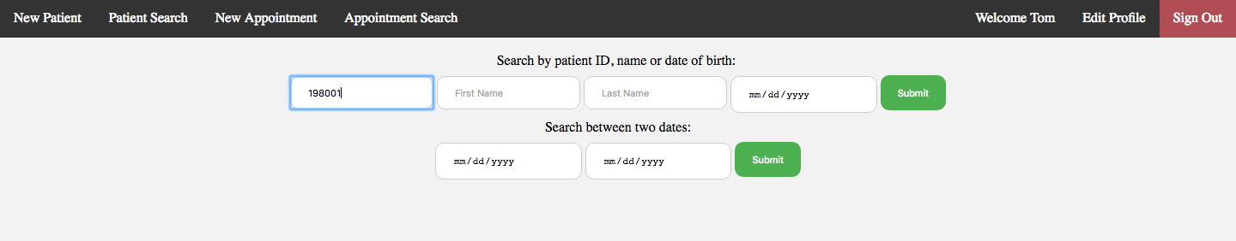

Patient search result:

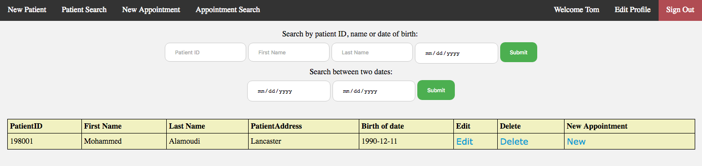

Edit patient search result:

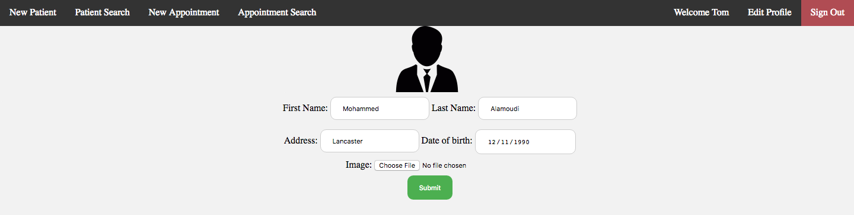

Add a new appointment:

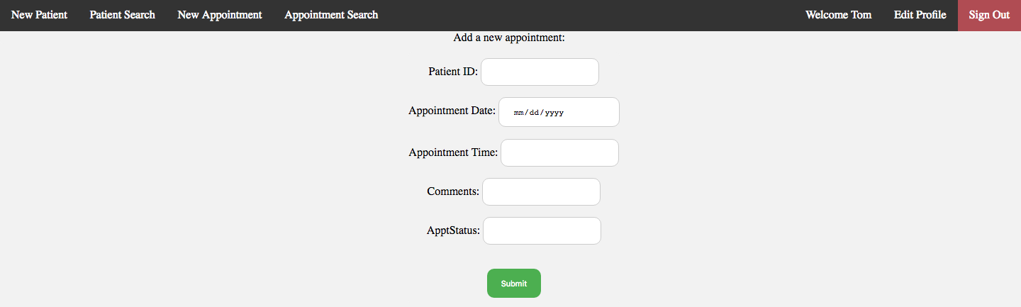

Appointment search:

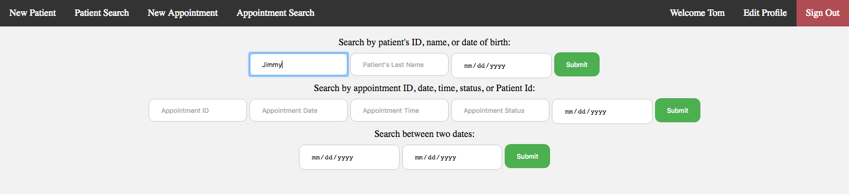

Search for Jimmy:

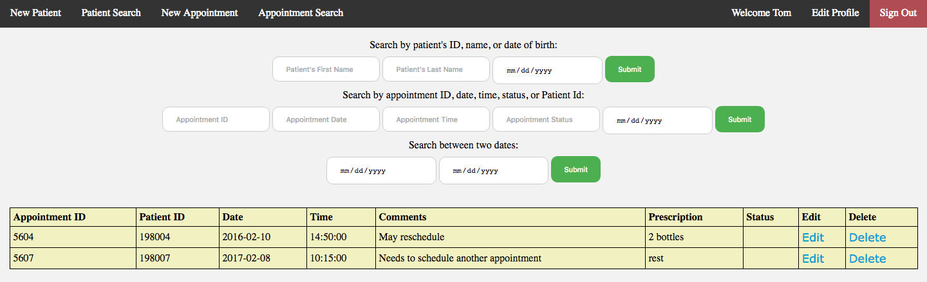

Edit appointment:

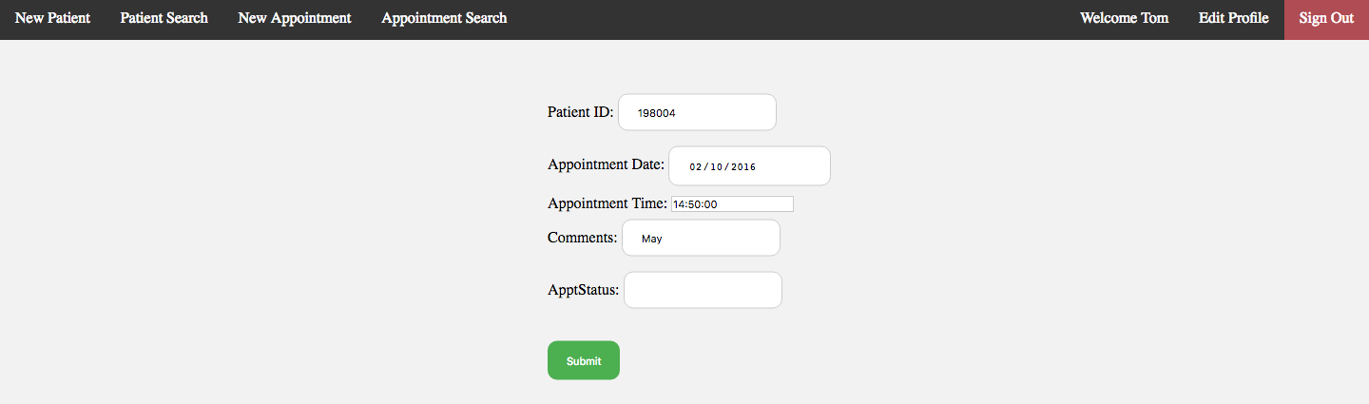

Search for appointment between two dates (12-05-2016 and 02-20-2017):

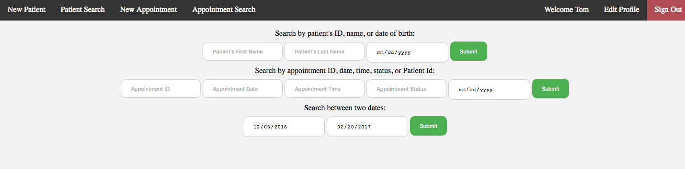

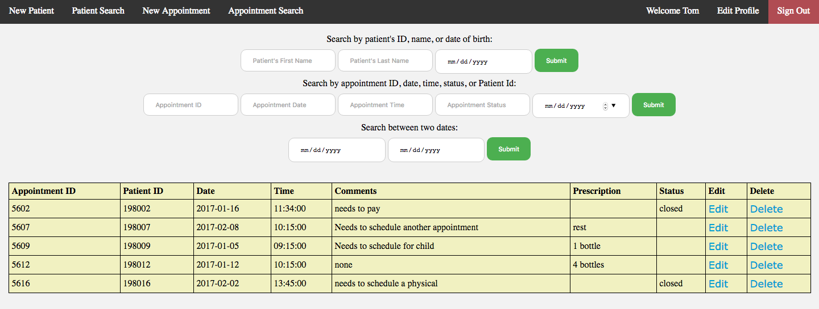

Edit receptionist profile:

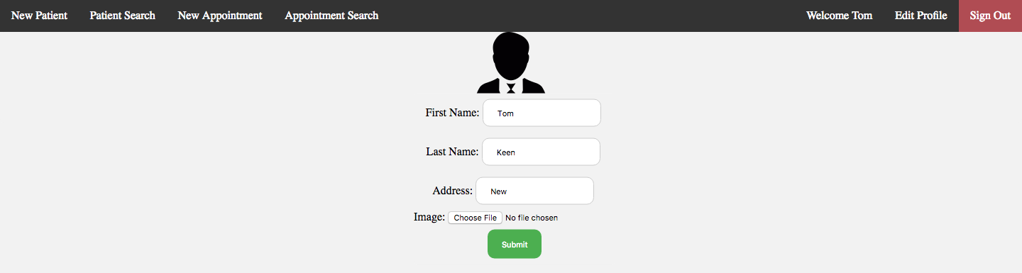

**Doctor Interface**

Home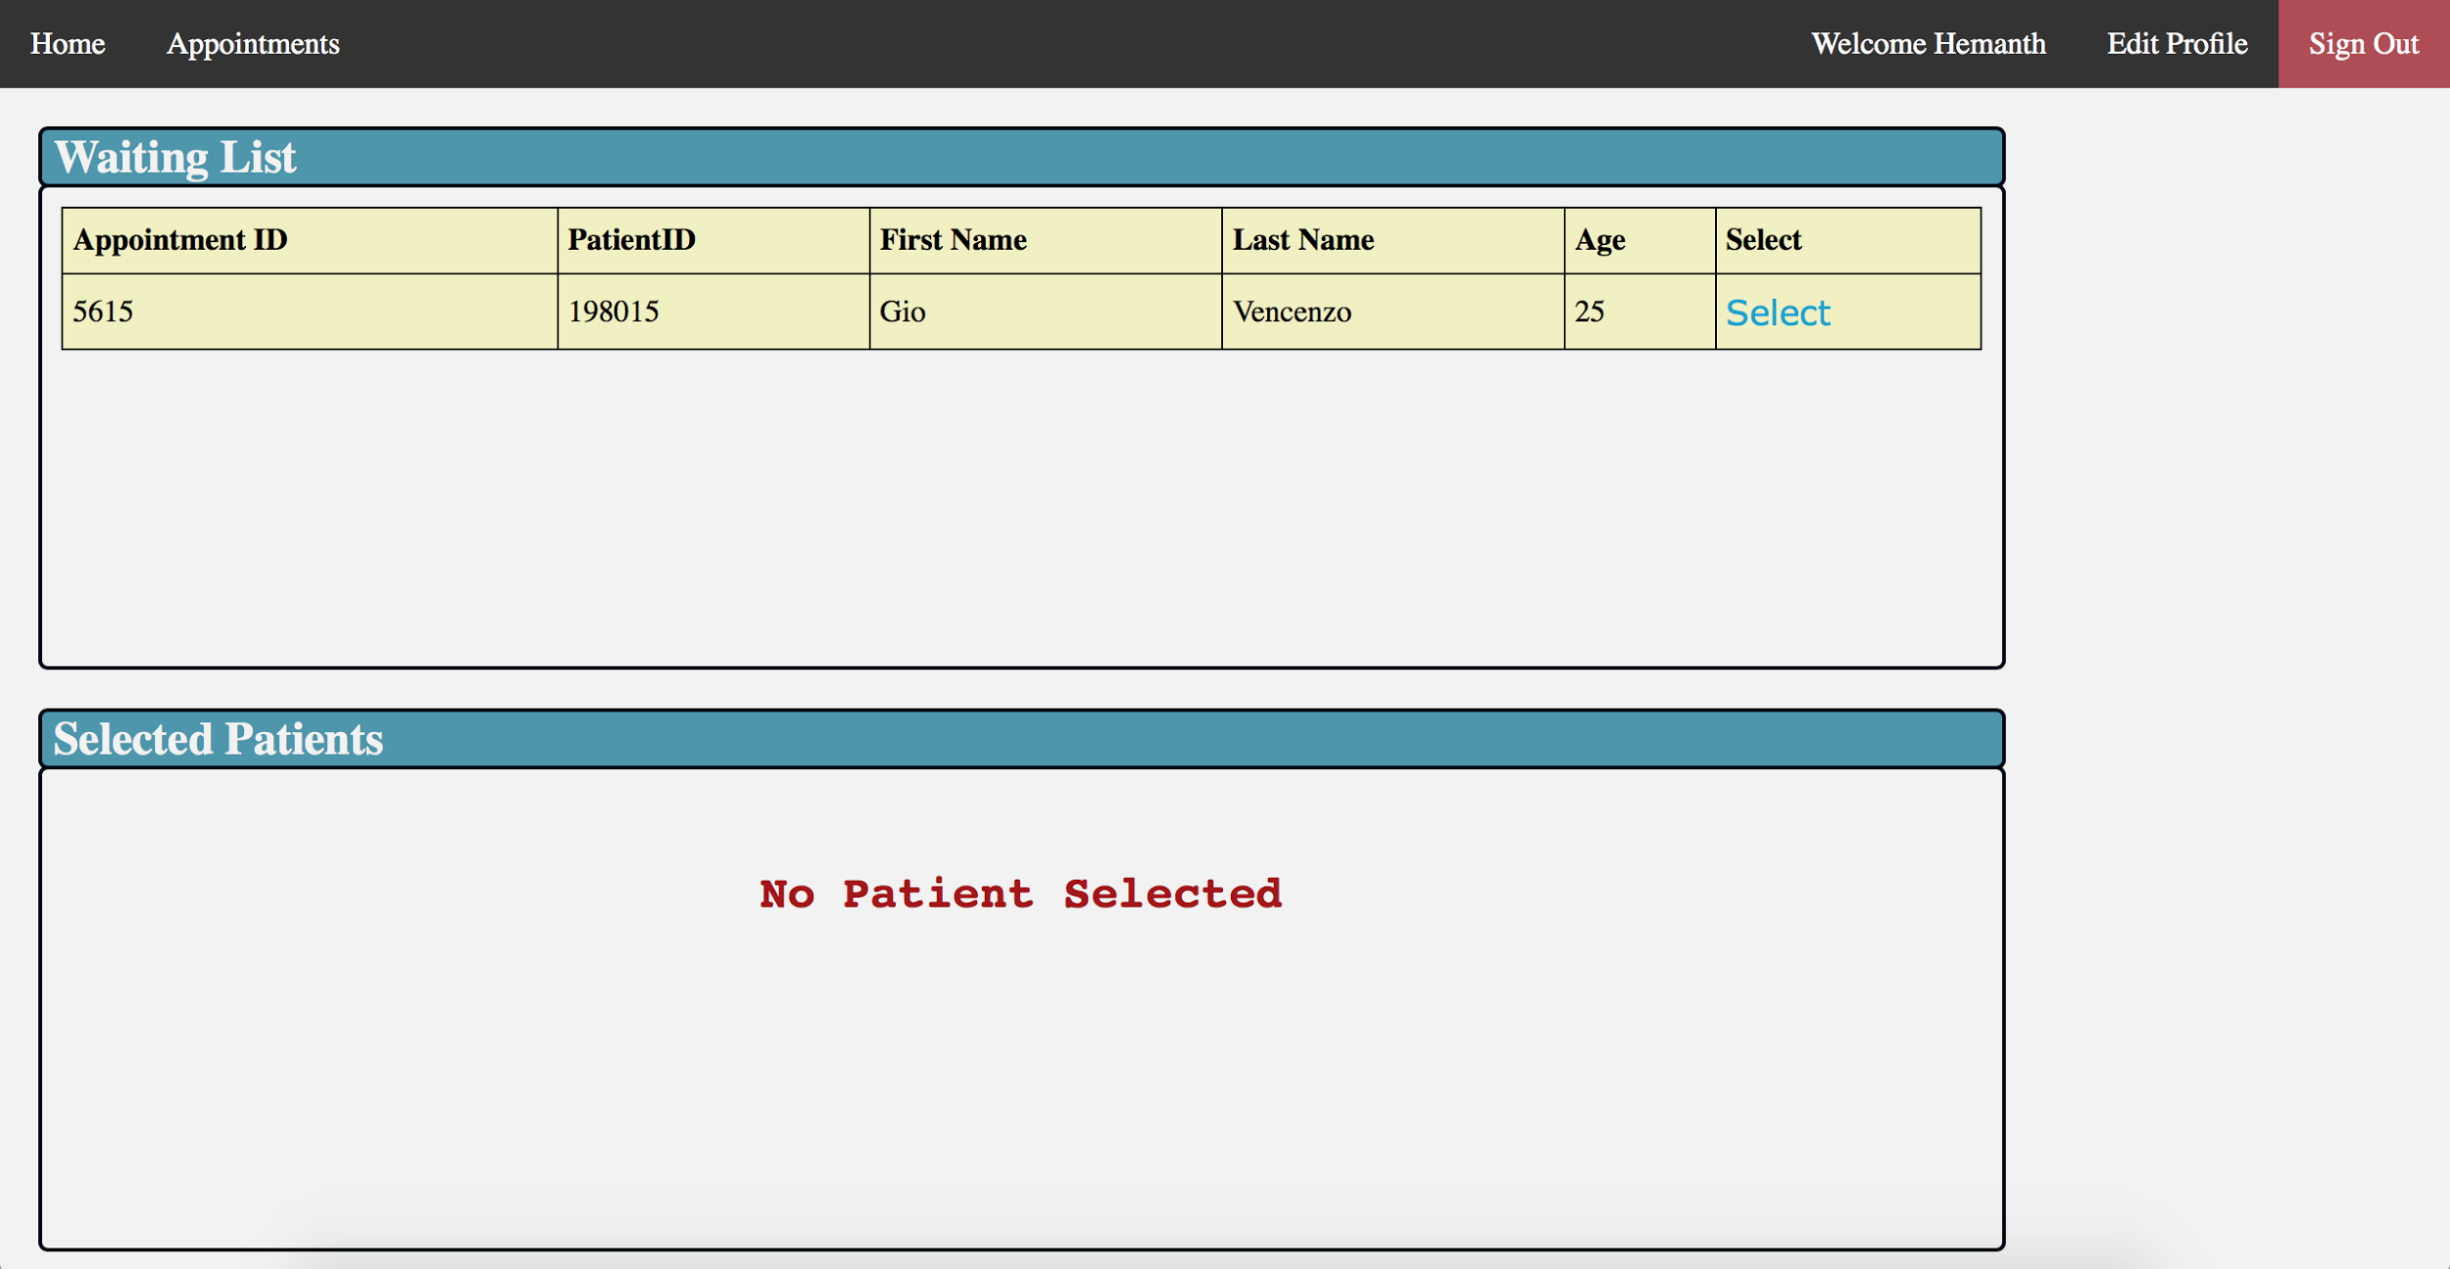

When a patient is Selected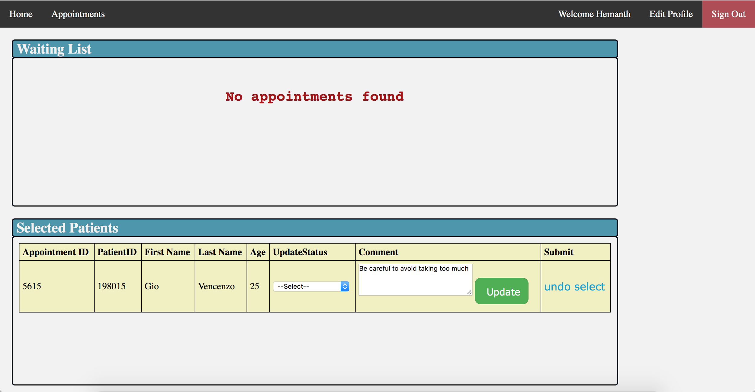

UpdateStatus DropDown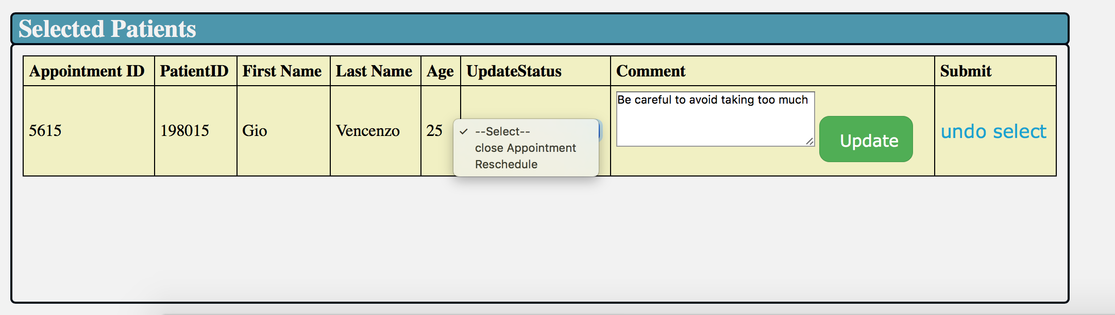

--Reschedule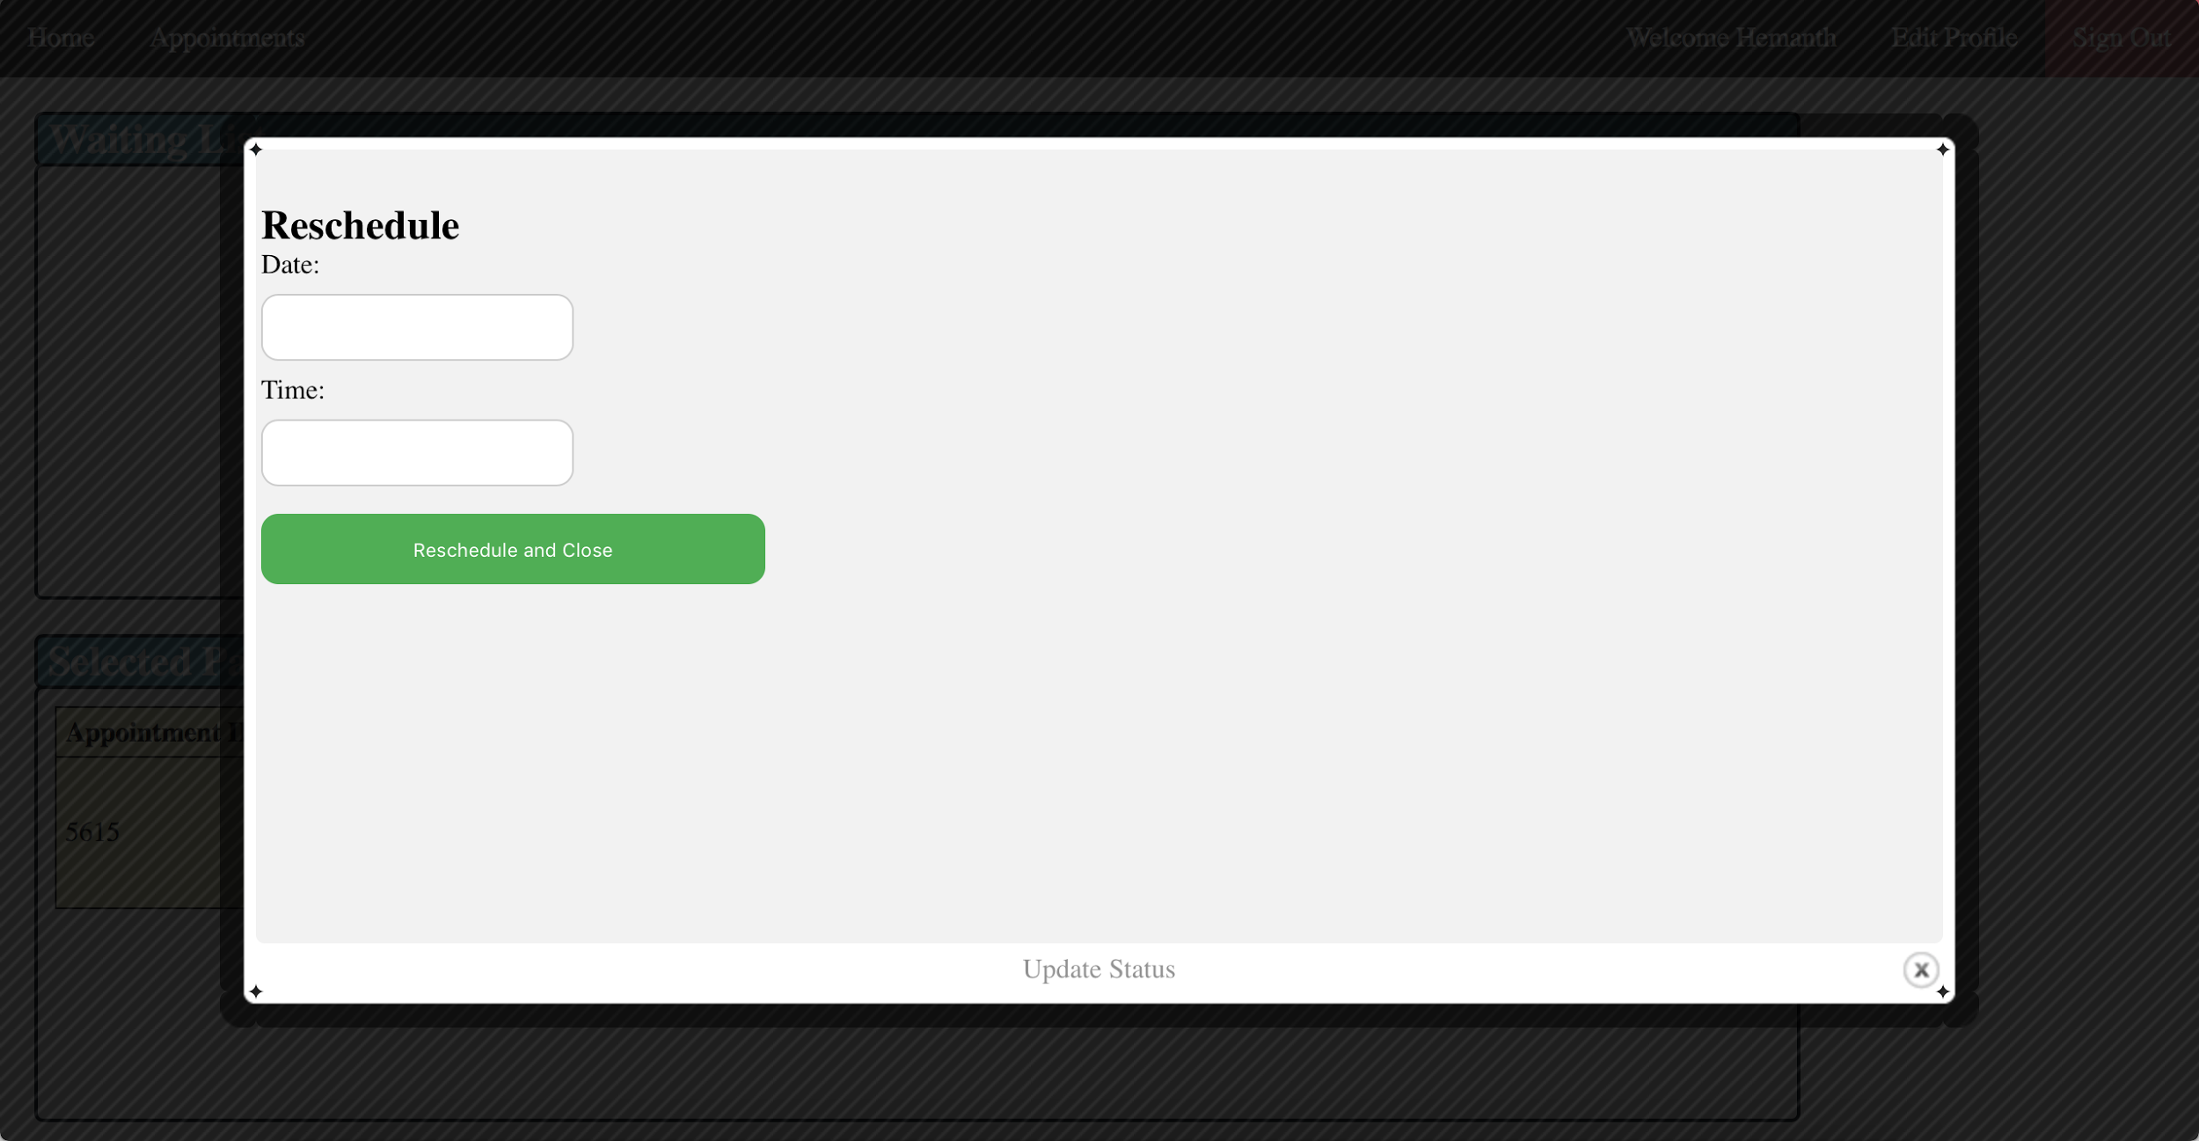

--Close Appointment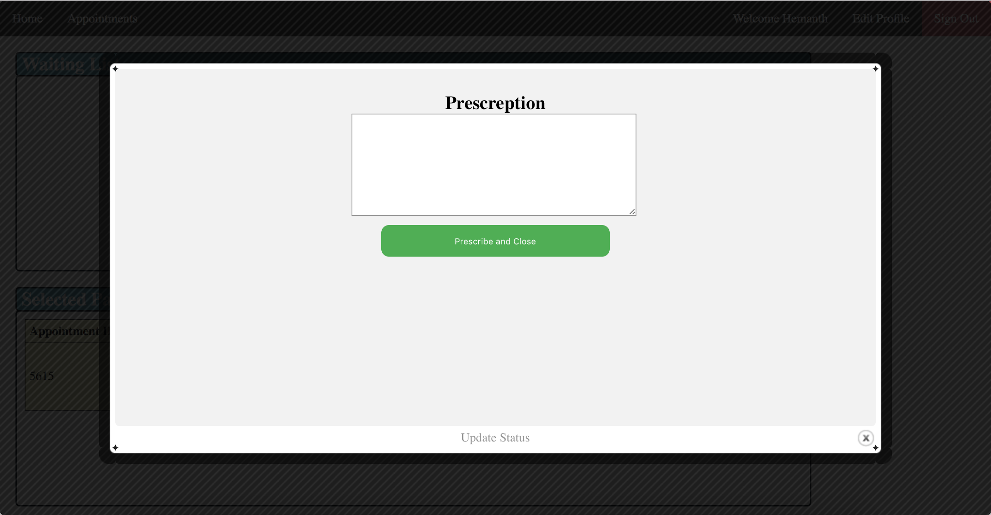

Appointments DropDown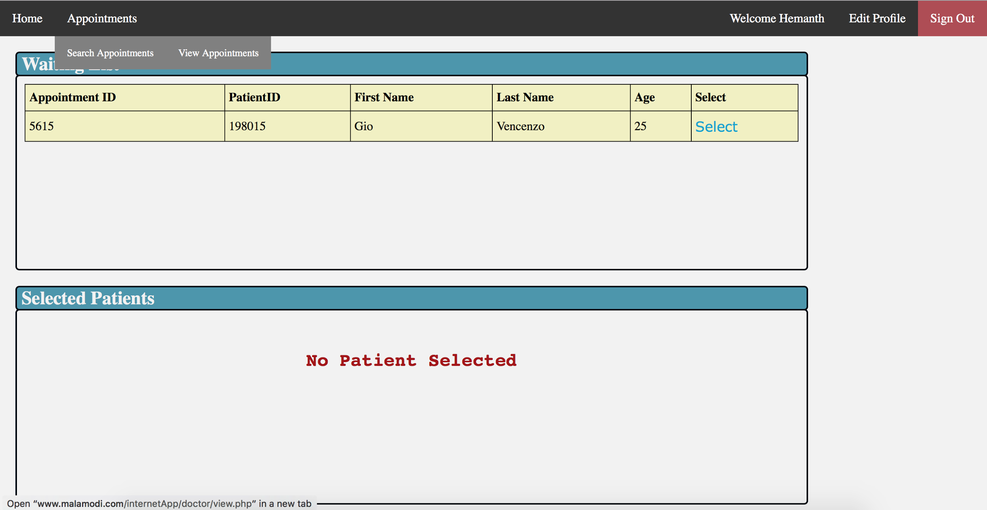

Search Appointment(With year)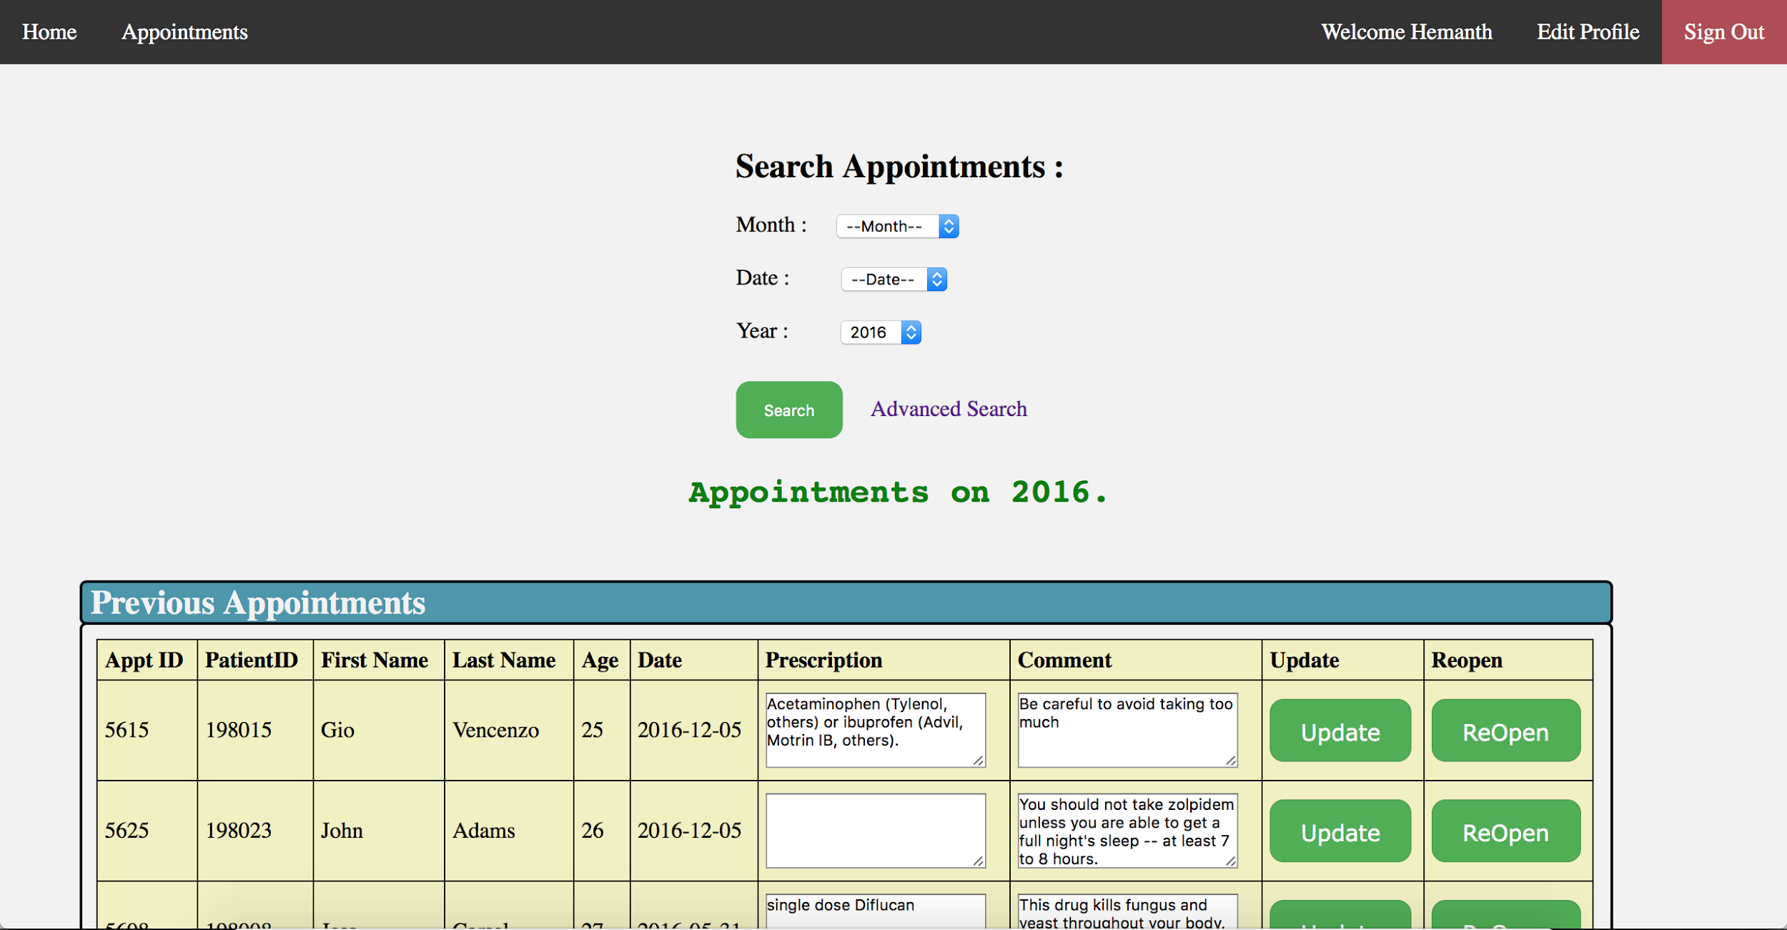

Search Appointment(With month and year)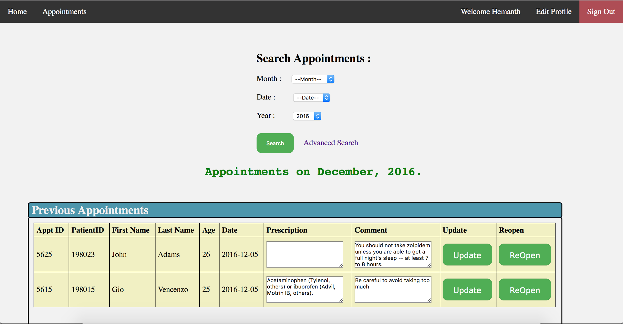

Search Appointment(With date, month and year)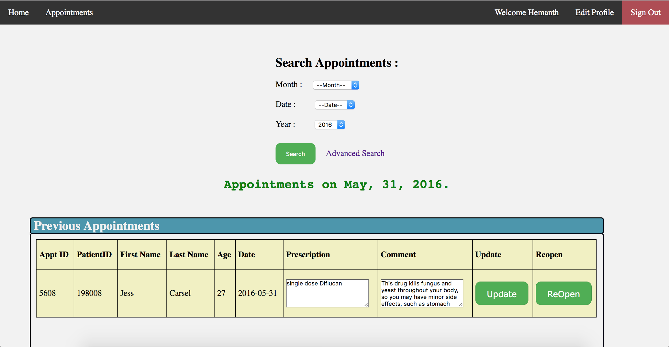

Advance Search(With first name: gio)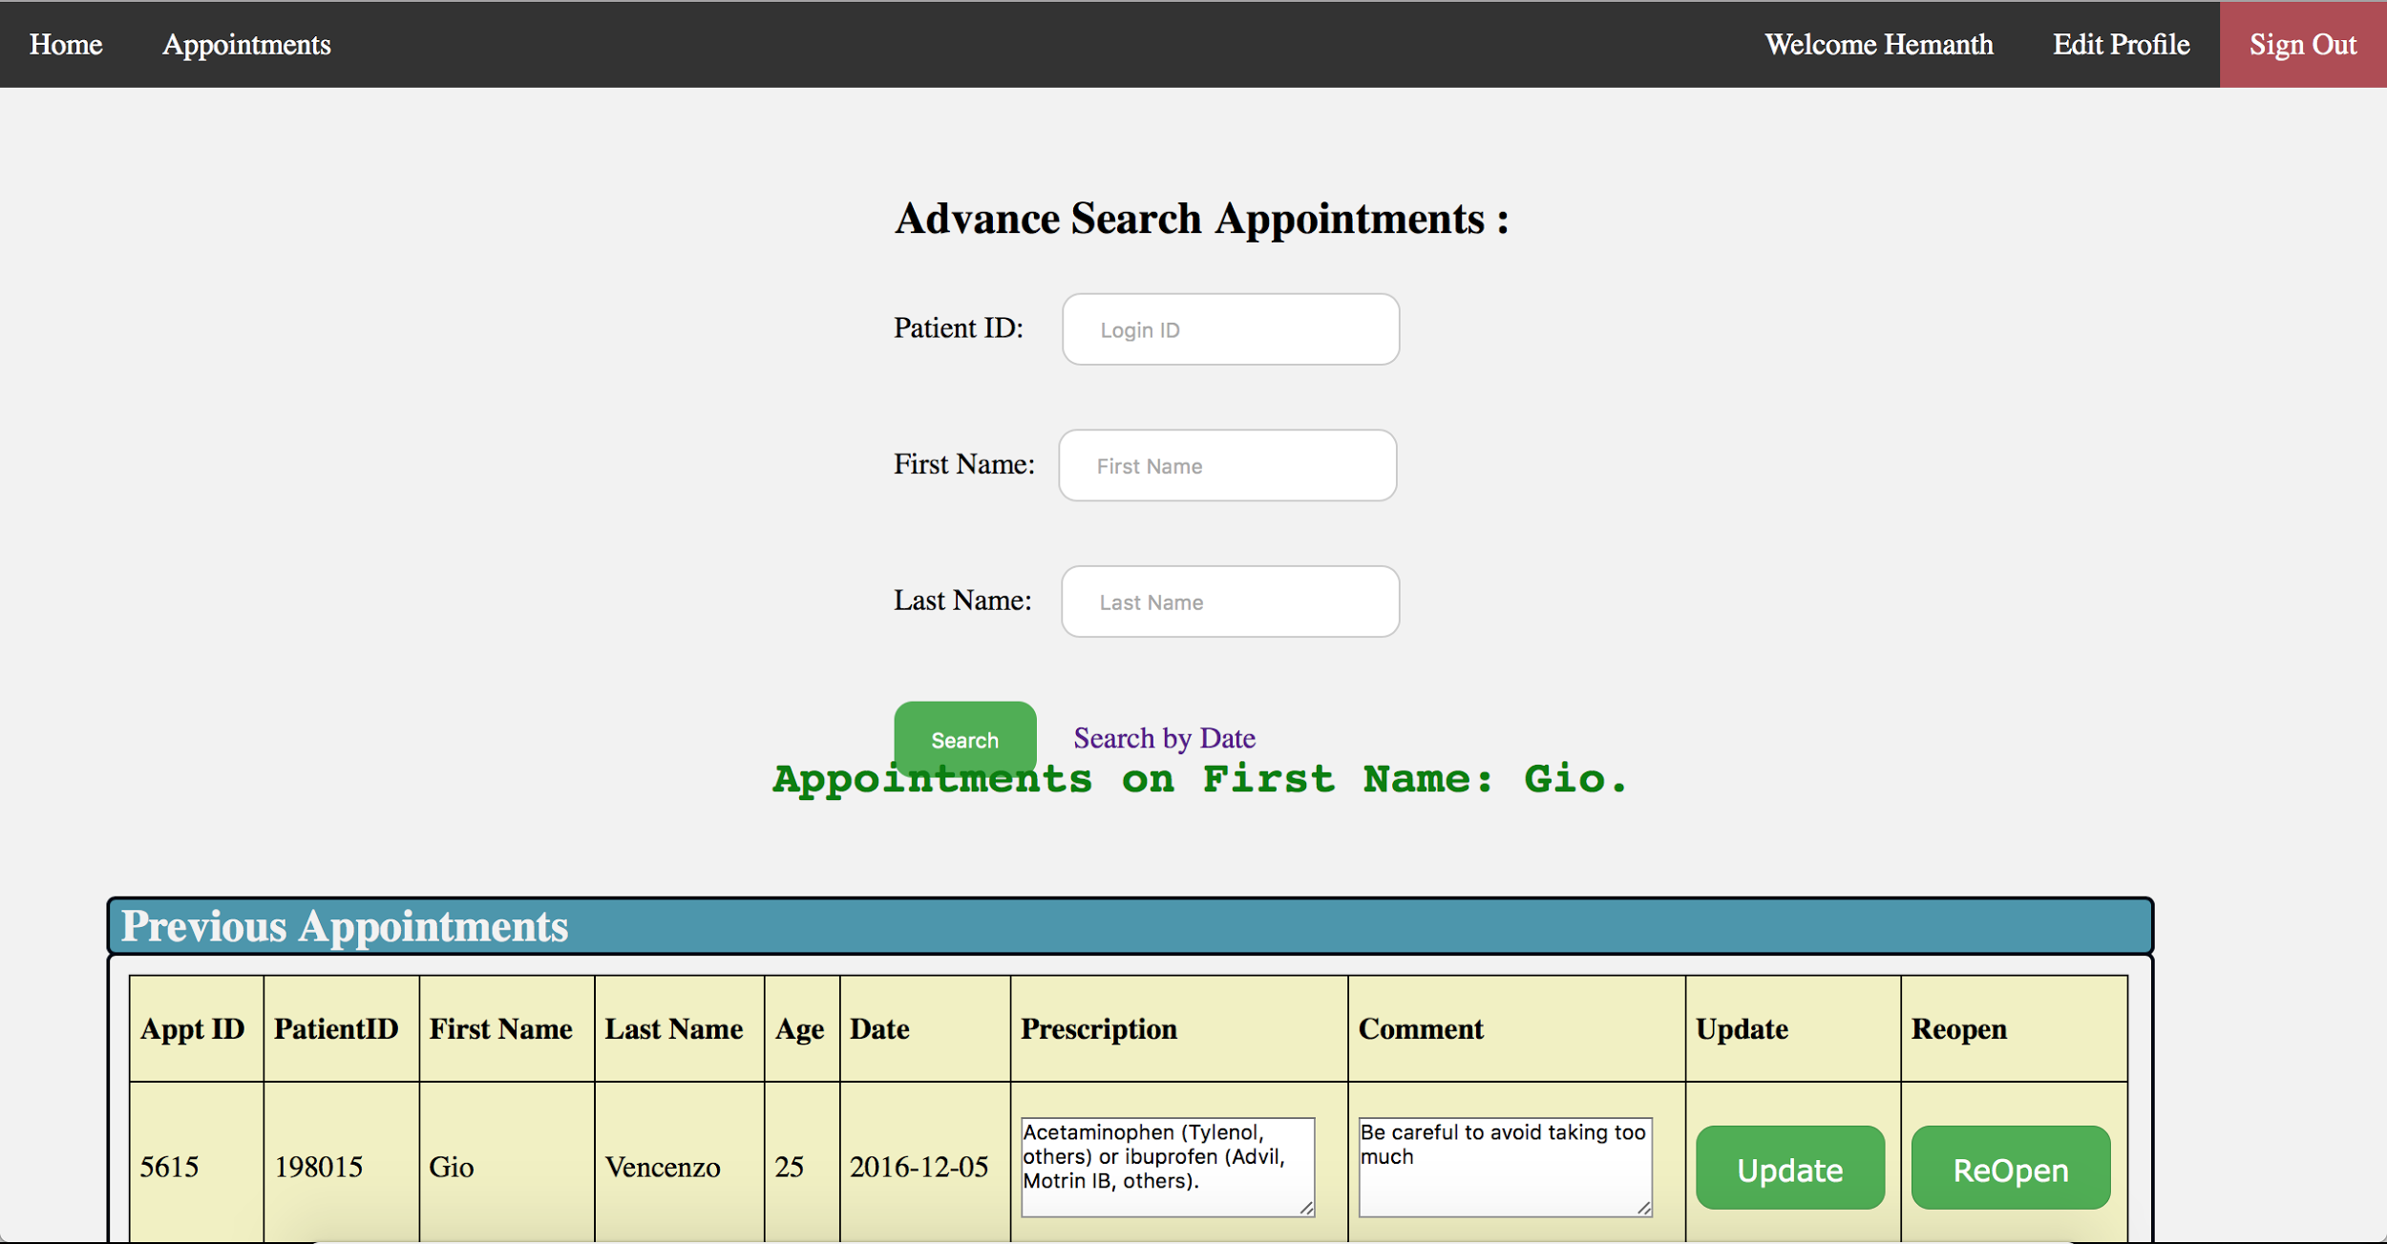

Update profile(when submit button clicked)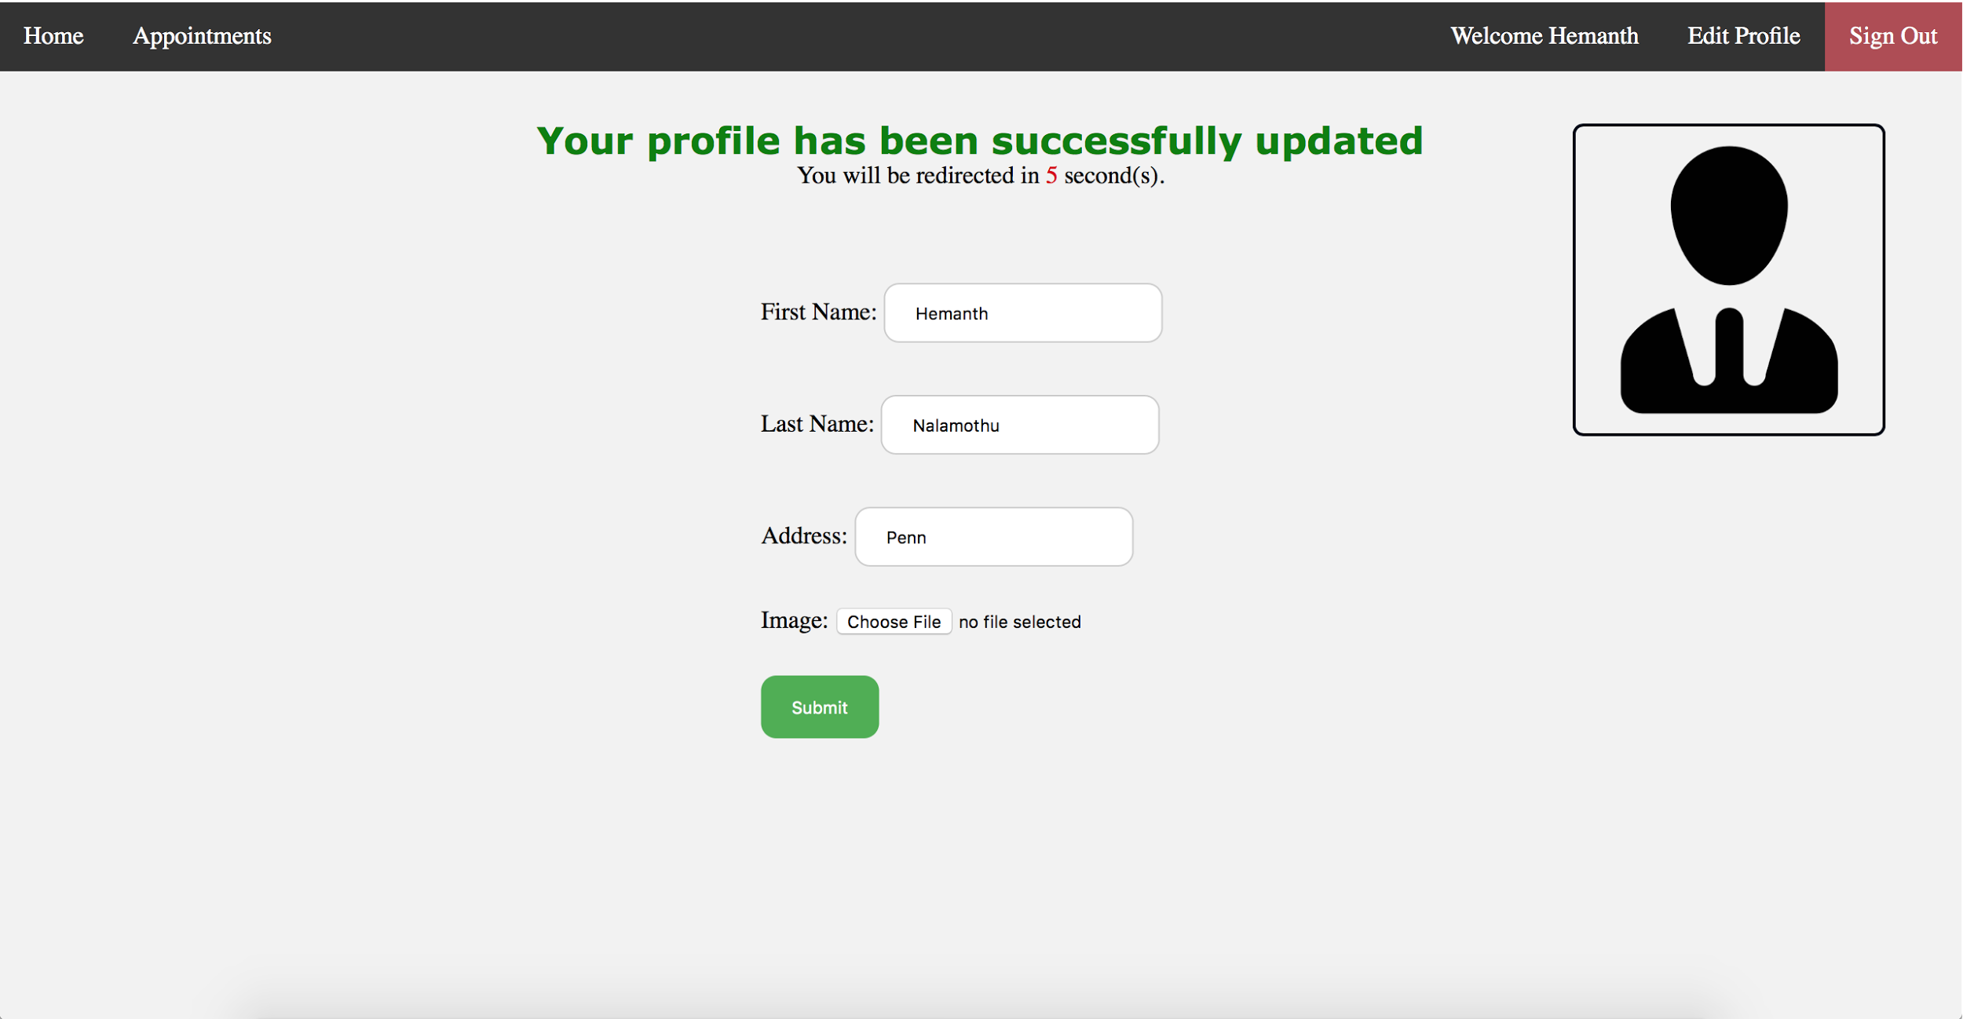

**Admin Interface**

Home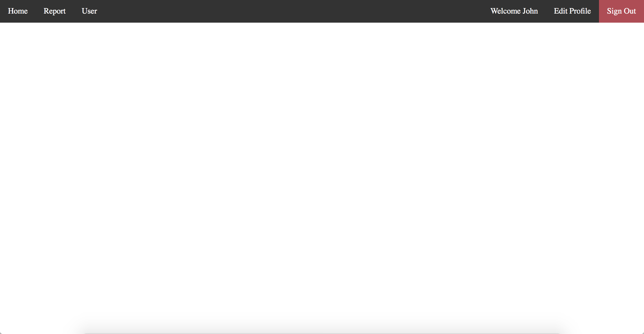

Report DropDown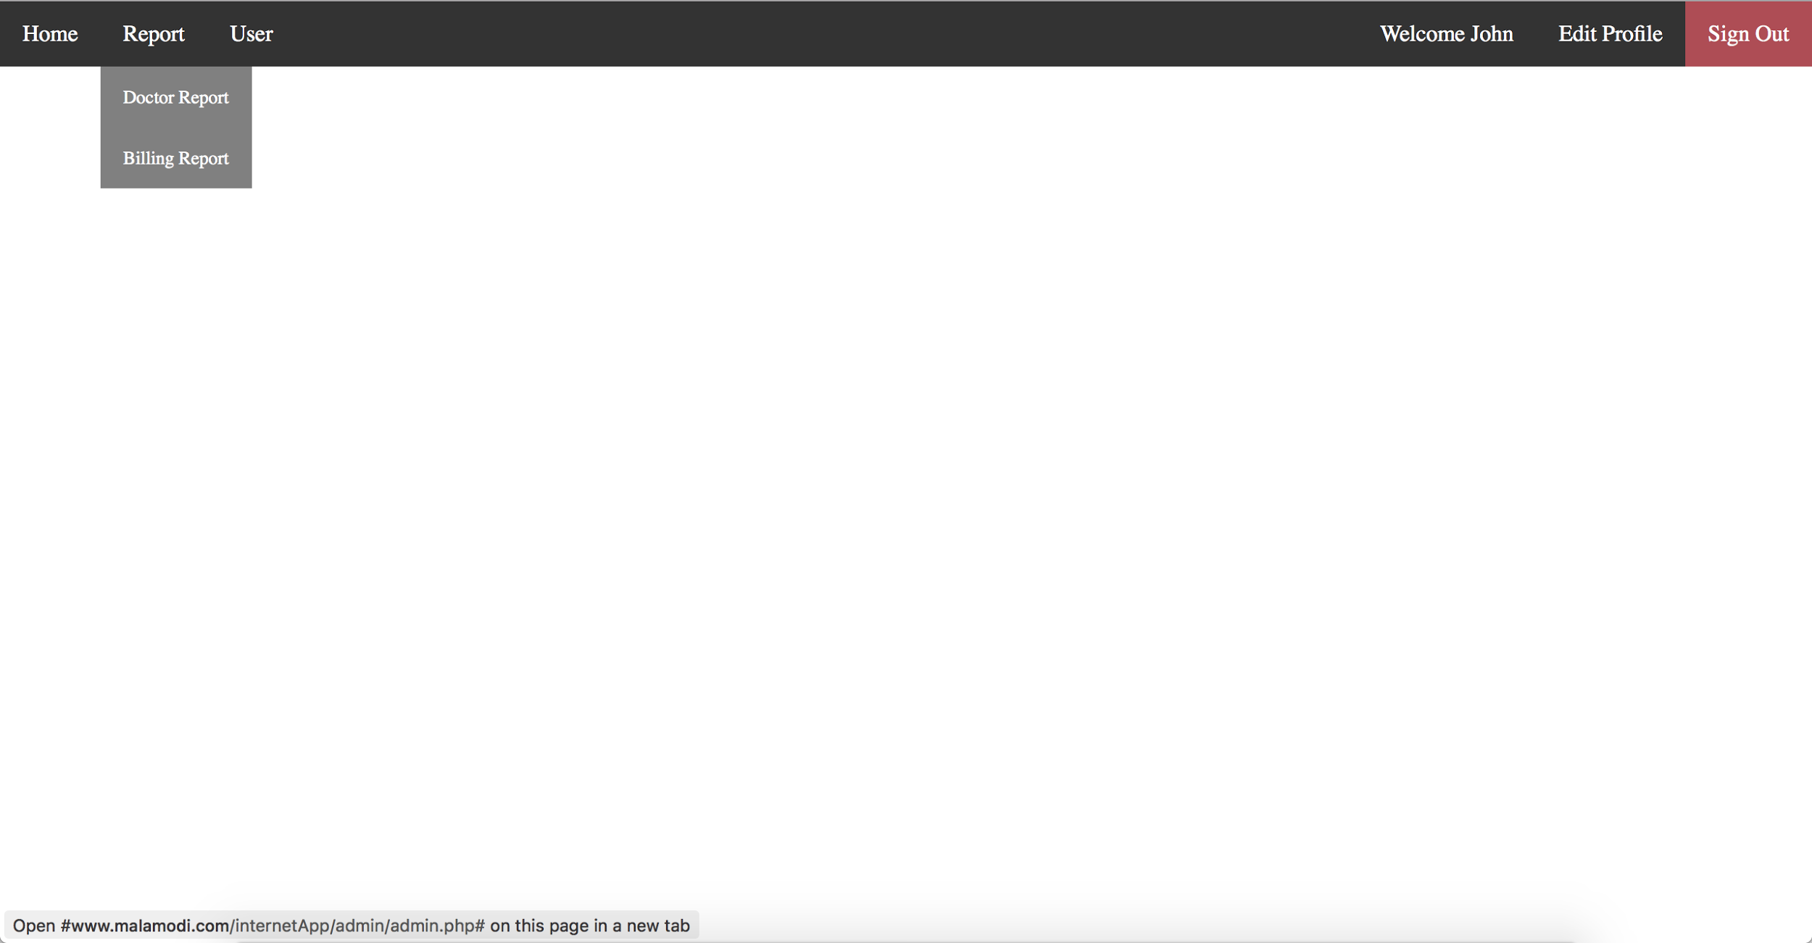

--Doctor Report(By year)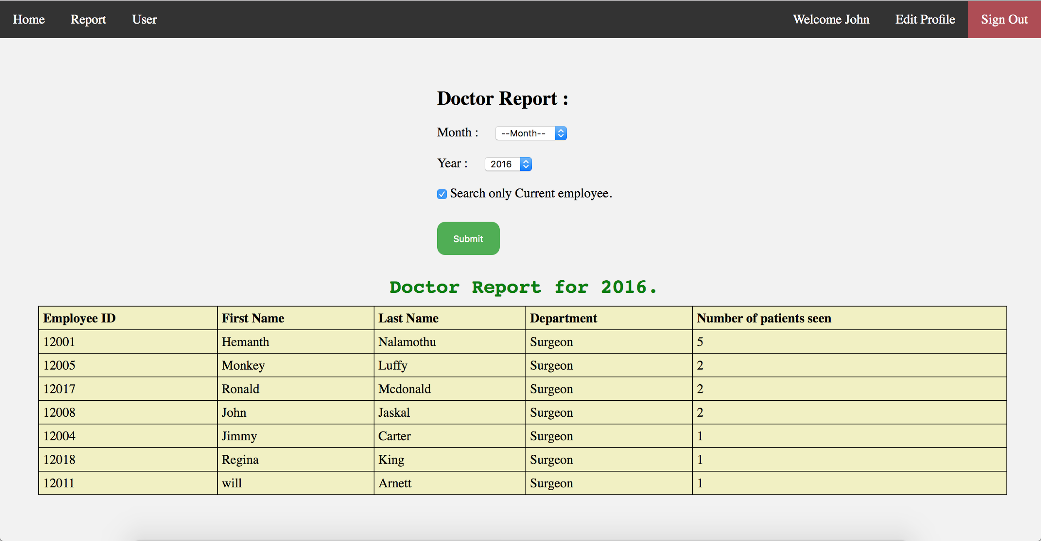

--Doctor Report(By month and year)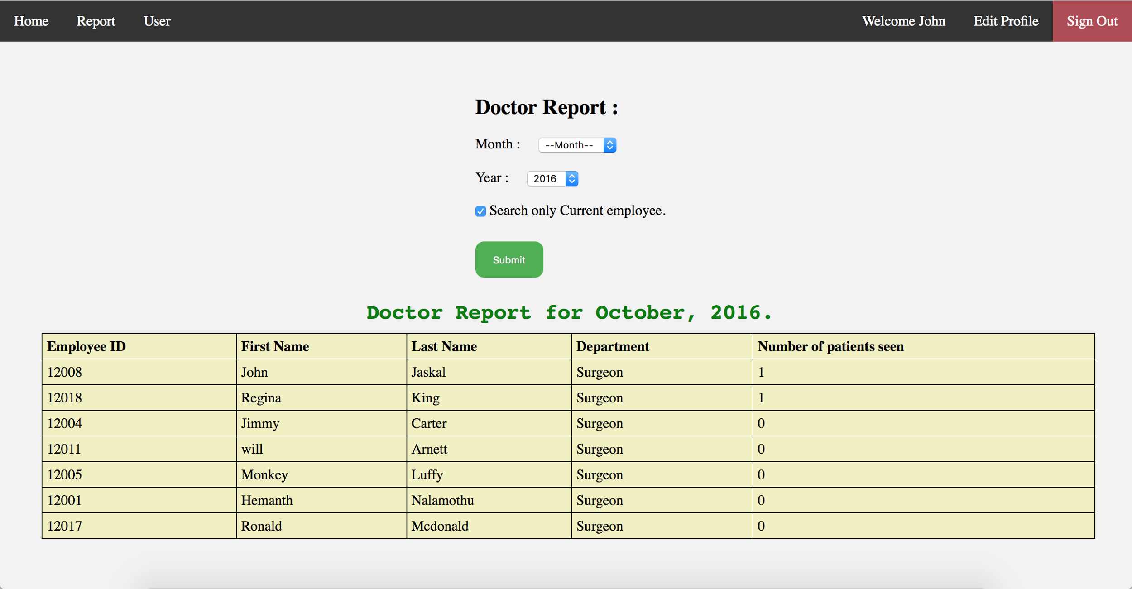

User DropDown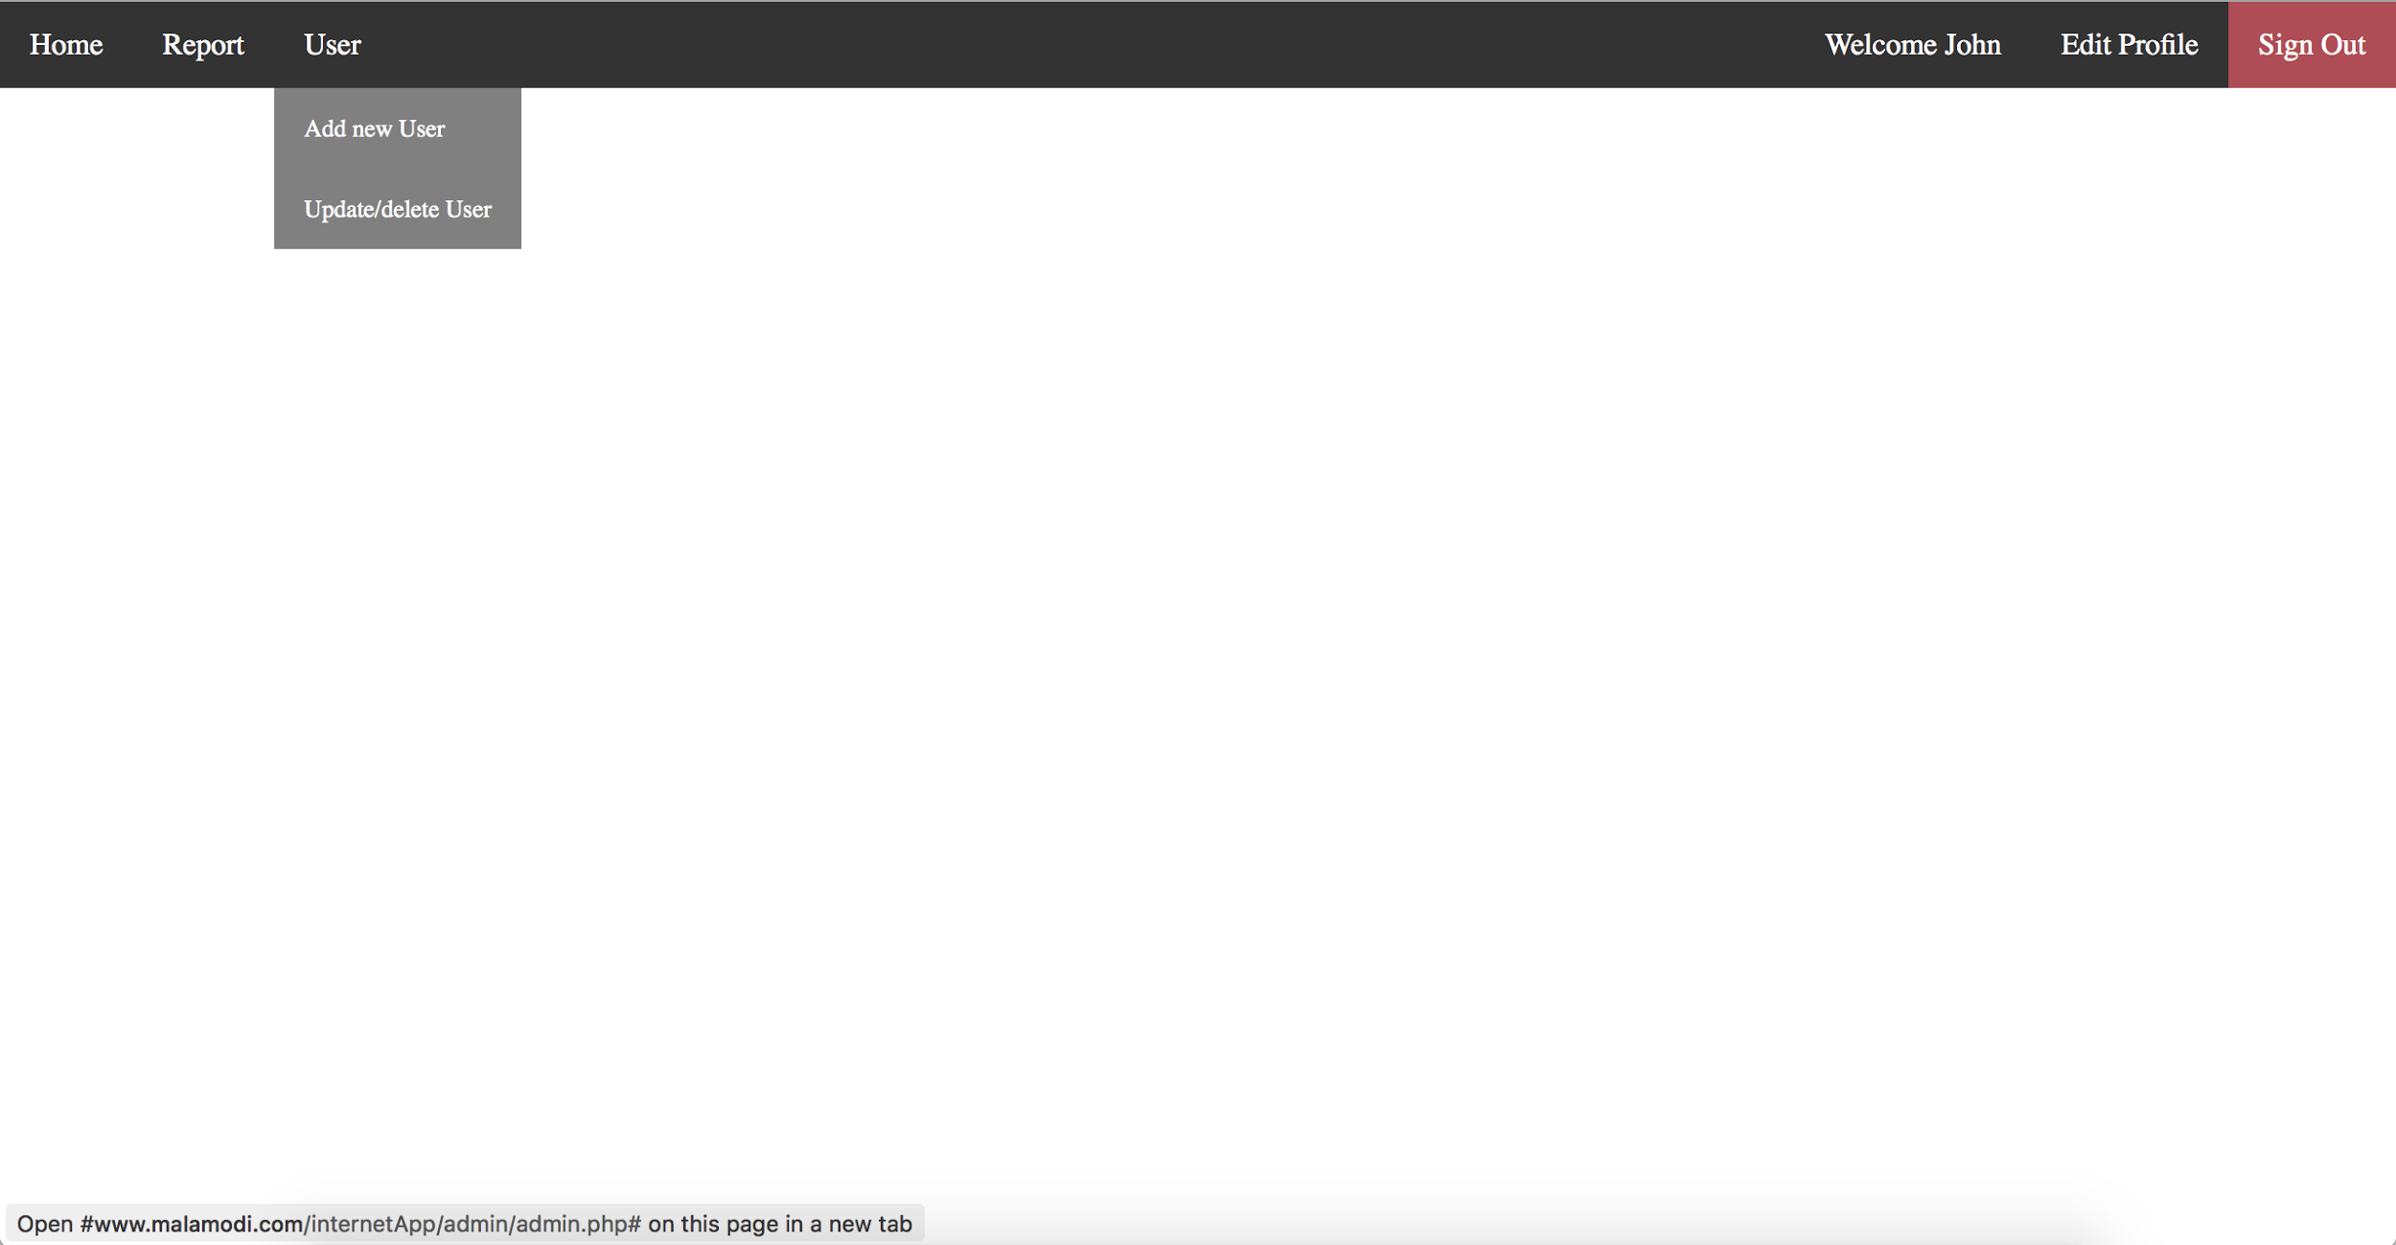

--Update/delete User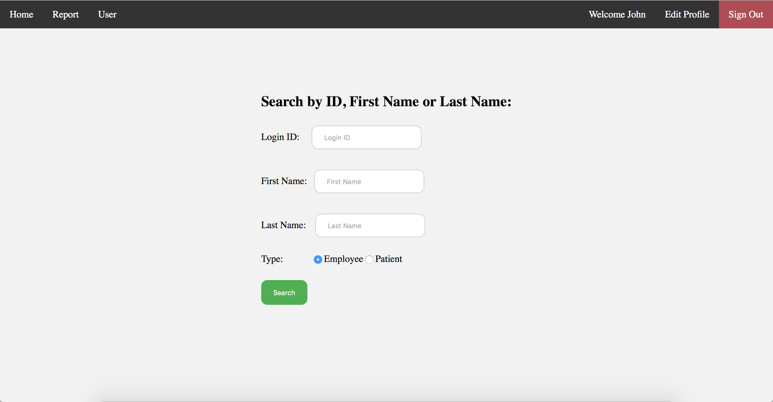

--Update/delete User(Search with first name: john)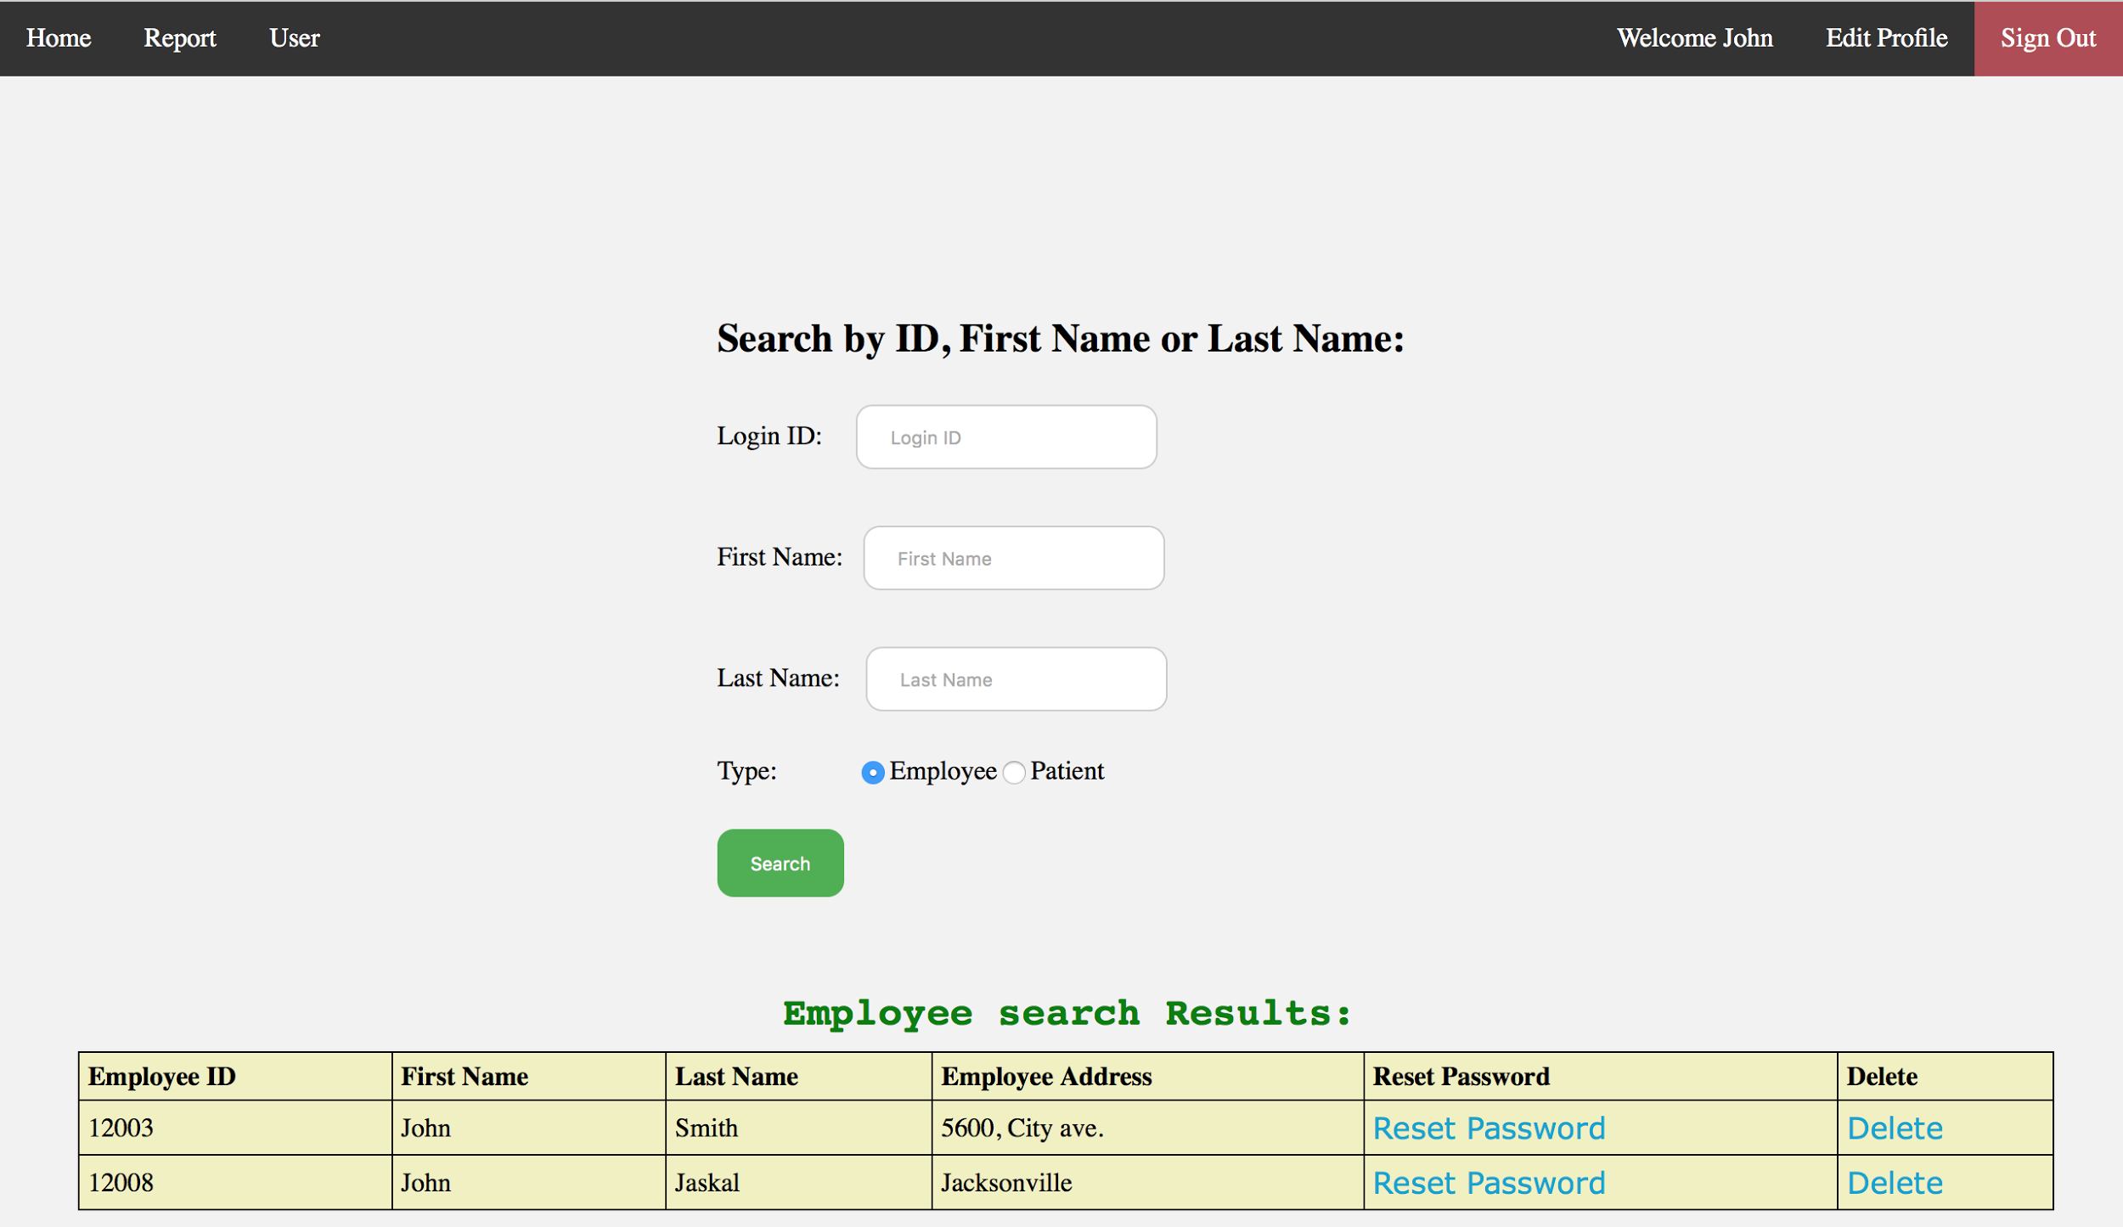

--Add new user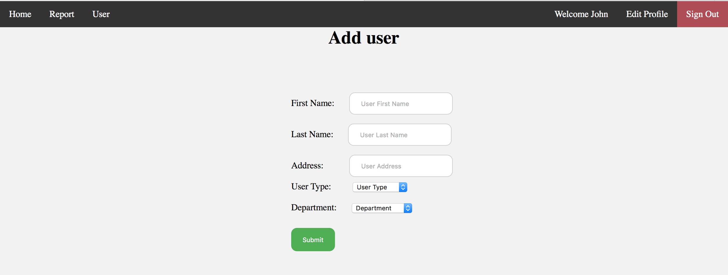

Edit Profile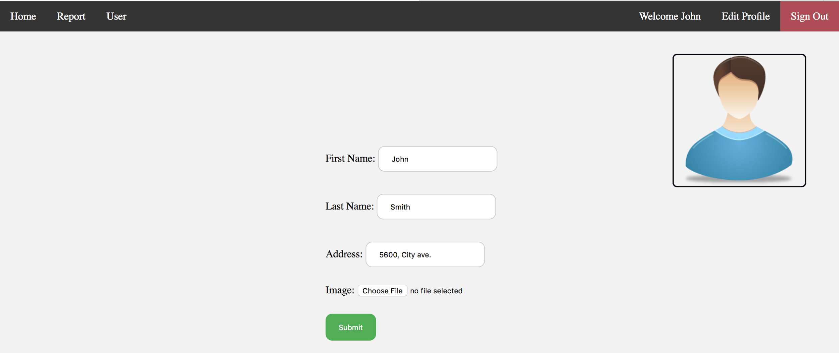

**Patient Interface**

Patient Home Page

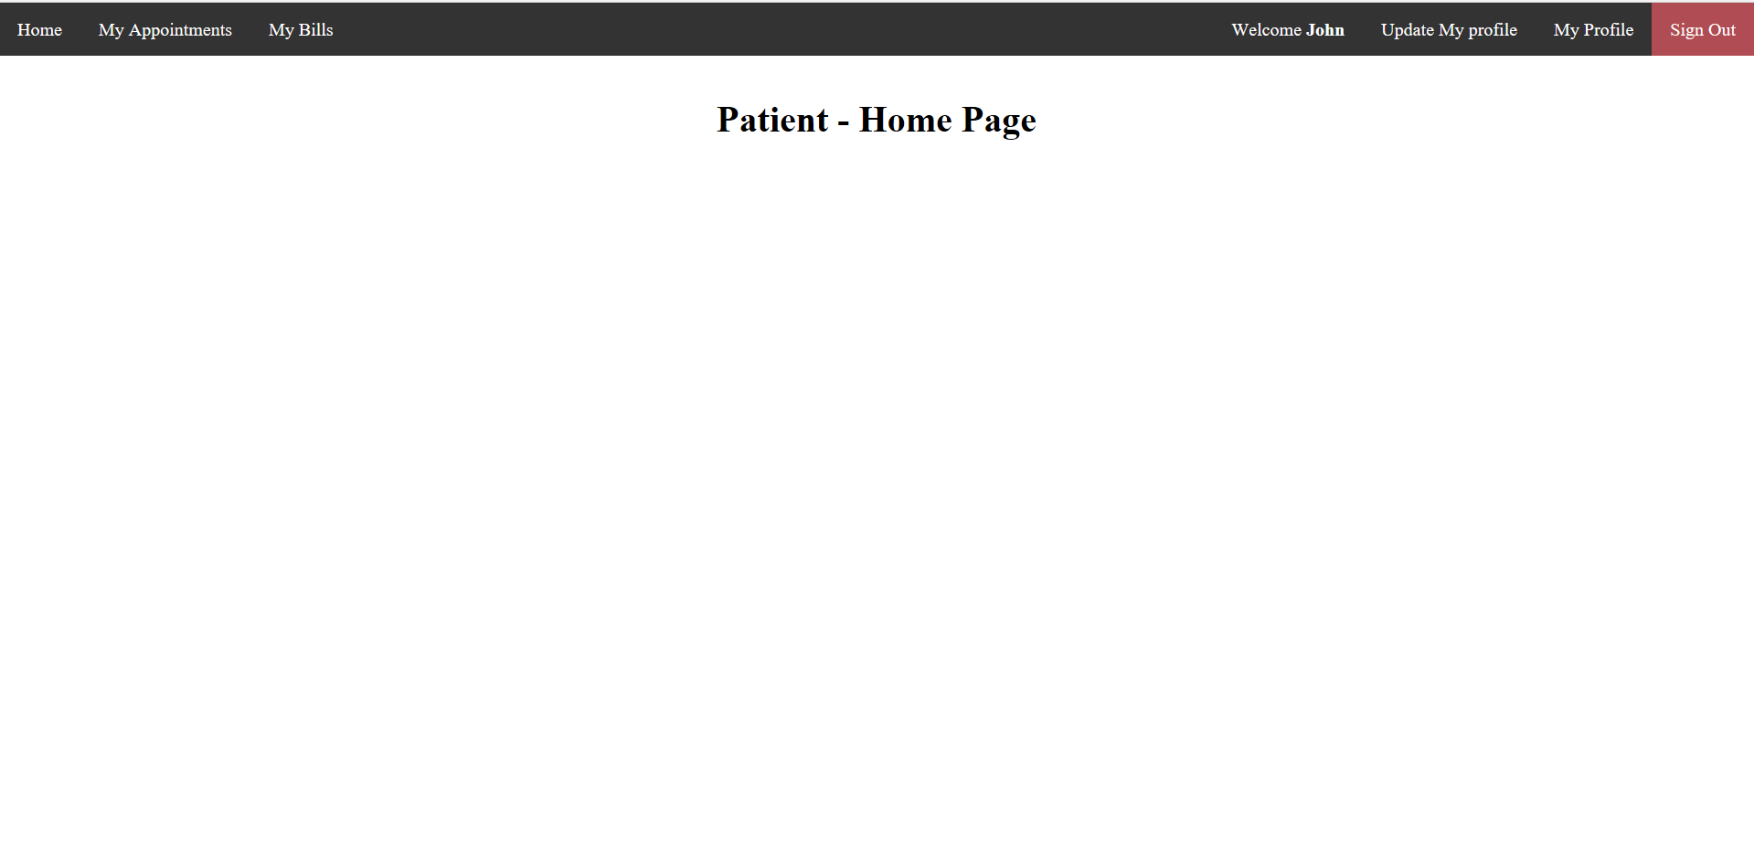

Viewing my appointments

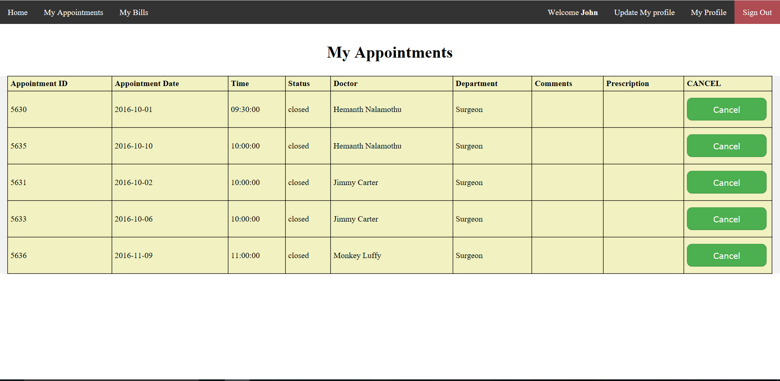

Viewing My bills

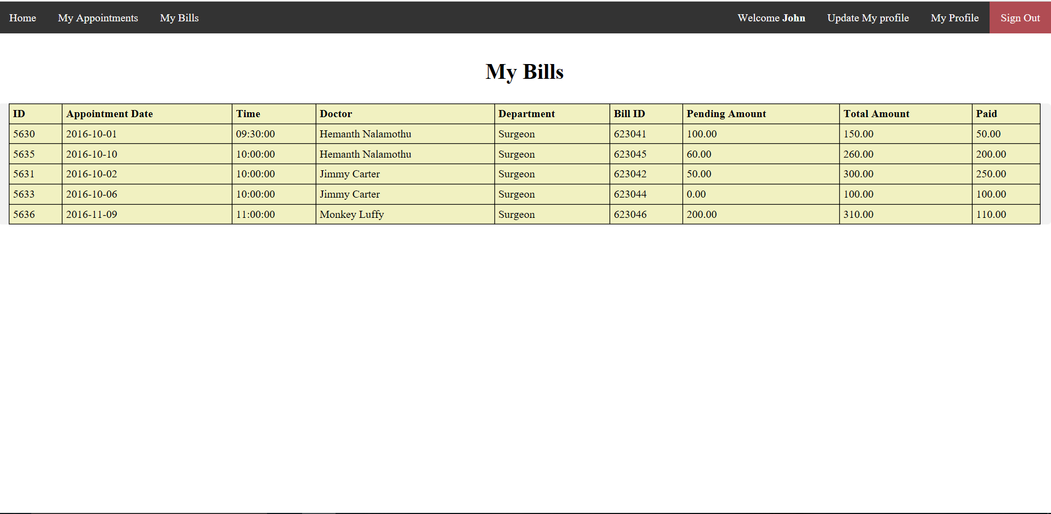

-Viewing my profile

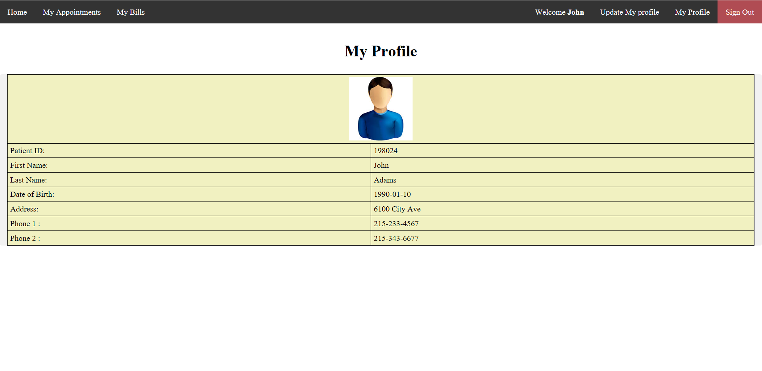

-Updating My Profile

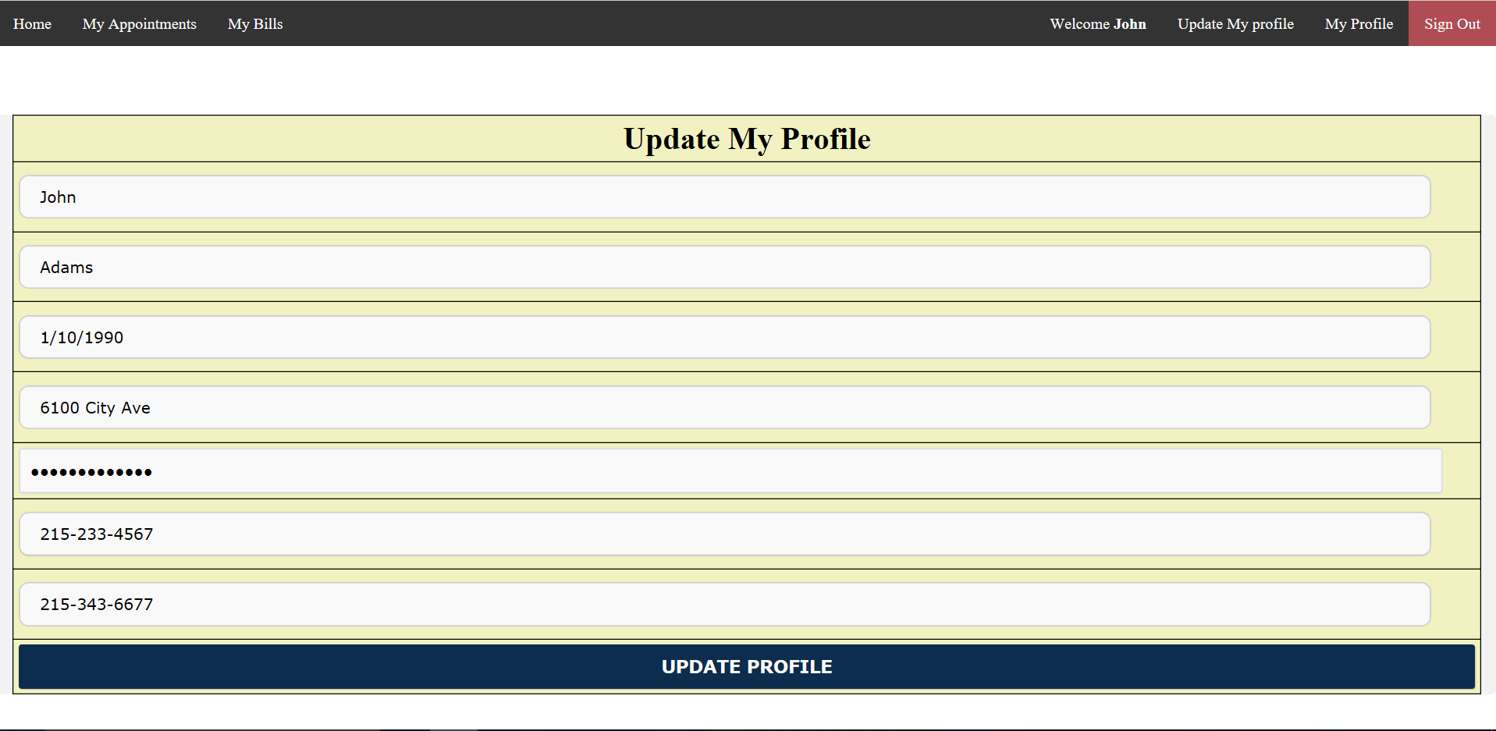

* **Discuss how you implement constraints**
  + We used unique keys for each table to identify and for mapping relationship between tables
  + We used foreign keys to populate tables
  + For each user we used a userType to identify the type of user and to redirect to the respective pages.
  + We used the doctor ID as appointment status to redirect patient to respective doctor
* **Discuss how you ensure integrity**
  + We have four kind of users each with a specific privileges.
  + Everyone within a table has an unique id
  + If a patient id matches an employee id they will not be able to access information due to being in different tables and the user type attribute is different.
  + We hashed password in the LoginDetails table.

* **Discuss updates that will require transactions be built**
  + we used the transaction while a doctor selecting an appointment so that no appointments get selected/updated twice(by two doctors).
* **Discuss error checking - non sensical data entered on form**
  + In the registration page, the first name, last name, date of birth, address, one phone number, and password are requirements but not the second phone number or the image.
  + In the receptionist interface, adding a new appointment will have to fill the patient id, appointment date, appointment time but not the comments and appointment status.
  + In Doctor interface:
    - When updating profile we made sure all the required input values are not empty and ensured the format of profile image upload is actually an image before updating
    - when rescheduling an appointment we validate the form for empty values and also the date(No date before current date) of the new appointment.
    - When searching/Advance search for appointment we check for empty input values and also date format.
    - We also added popup for confirmation before reopening a closed appointment.
  + In Admin interface:
    - When updating profile we make sure all the required input values are not empty and ensured the format of profile image upload is actually an image before updating
    - When searching for users we check for empty input values
    - When creating a new user we make sure all the values are entered correctly and all the required options are selected
  + In Recipeniest interface:
    - when creating a new patient we make sure all the required fields are filled.
    - when adding a new appointment we make sure all the required fields are filled with correct values and not the optional ones.
  + In Patient Interface:

In update profile page, the patient can not submit empty form or fields with empty value

**identify 3 indexes other than primary key:**

* PatientFName and PatientLName for Patient table
* EmpFName and EmpLName for Employee

**Table for assigned pieces:**

|  |  |  |
| --- | --- | --- |
| **Peace Assigned:** | **Names:** | **Due Date:** |
| **ER Diagram** | * Hemnth Nalamothu * Mohammed Alamoudi * Mohammed Alduniawi | Nov/6/2016 |
| **Relational Model** | * Hemnth Nalamothu * Mohammed Alamoudi * Mohammed Alduniawi | Nov 10, 2016 |
| **Reviewing ER Diagram** | * Victor Logan * Mohammed Alduniawi | Nov 7, 2016 |
| **Reviewing Relational Model** | * Victor Logan | Nov 11, 2016 |
| **Create Database & Tables** | * Mohammed Alduniawi | Nov 17, 2016 |
| **Insert Data to Tables** | * Victor Logan | Nov 19, 2016 |
| **Review Database & Tables** | * Mohammed Alamoudi * Hemnth Nalamothu * Mohammed Alduniawi | Nov 18, 2016 |
| **Review after Inserting Data to Tables** | * Mohammed Alamoudi * Hemnth Nalamothu | Nov 20,2016 |
| **Create Queries** | * Victor Logan | TBA |
| **Login page** | * Mohammed Alamoudi | Nov/20/2016 |
| **Doctor interface** | * Hemanth Nalamothu | Nov/30/2016 |
| **Patient interface** | * Mohammed Alduniawi | Nov 30, 2016 |
| **Receptionist interface** | * Mohammed Alamoudi | Nov/30/2016 |
| **Admin interface** | * Hemanth Nalamothu | Nov/30/2016 |
| **Home Page and Design (HTML & CSS)** | * Mohammed Alamoudi * Hemanth Nalamothu * Mohammed Alduniawi * Victor Logan | Nov/30/2016 |
| **PHP (Database Connection & Queries)** | * Mohammed Alduniawi | TBA |
| **Testing** | * Victor Logan | TBA |

**Members ranking:**

**Member 1 : Mohammed Alamoudi**

My teammates and I agrees I did 30% of the overall project.  My specific tasks include

Task 1 : I helped Hemanth to do the ERD.

Task 2 : I helped Hemanth to do the relational model.

Task 3 : I coded the login/logout pages.

Task 4 : I coded the header design.

Task 5 : I helped writing the first, second, and final reports.

Task 6 : I wrote the code for the receptionist.

Task 7 : I helped doing the website design.

**Member 2 : Hemanth Nalamothu**

My teammates and I agrees I did 30% of the overall project.  My specific tasks include

Task 1 : I did ERD and Relational Schema.

Task 2 : I wrote code for Doctor and Admin Pages

Task 3 : I designed the database format and Database Requirements.

Task 4 : I involved in completion of first, second, and final reports.

**Member 3: Mohammed Alduniawi**

My teammates and I agrees I did 25 % of the overall project.  My specific tasks include:

Task 1: I worked with Hemanth and Mohammed in preparing the ERD for the project.

Task 2: I reviewed the relational schema

Task 3: I worked in the database development process for the project

Task 4: I worked in the patient interface and I wrote the code for the Patient pages

Task 5: I helped in writing the first, second, and the final reports

**Member 4: Victor Logan**

My teammates and I agrees I did 15 % of the overall project.  My specific tasks include:

Task 1:I helped create the overview of database and wrote the first report

Task 2: review the relational schema and ER diagram

Task 3: insert data into database with SQL

Task 4: I helped write the final report

Finally we uploaded the project to this link:

<http://www.malamodi.com/internetApp/login/index.php>

And those are the user id’s and passwords for the four type of users to test it:

|  |  |  |  |  |
| --- | --- | --- | --- | --- |
|  | **Patient** | **Receptionist** | **Admin** | **Doctor** |
| **User ID** | 198024 | 12007 | 12003 | 12001 |
| **Password** | 198024 | 12007 | 12003 | 12001 |